Romans 4 Abraham was declared righteous through faith ES
Romanos 4 Abraham fue declarado justo por la fe ES

Lesson developed by John M. Wharton March 21, 2023
http://www.biblestudyadventures.com/
Sources -
From theWord Bible program http://www.theword.net/ . Generally King James Version.
Greek, Hebrew definitions Mickelson's Enhanced Strong's, Brown-Driver-Briggs', Thayer's generally.

In Romans 4, Paul explains that if a person is justified by their religious works then God is paying them by declaring them righteous. They have earned it. It is not a gift.  Now Abraham's faith was counted to him as righteousness. And he was declared righteous by God before he was given circumcision.  So his righteousness wasn't from works and circumcision.  Paul's concludes that the law only gets us wrath because of our sins. But God's plan is righteousness through our faith in God's promise to accept us in Christ. | En Romanos 4, Pablo explica que si una persona es justificada por sus obras religiosas, entonces Dios le está pagando al declararla justa. Lo han ganado. No es un regalo.  Ahora bien, la fe de Abraham le fue contada por justicia. Y fue declarado justo por Dios antes de que se le diera la circuncisión.  Así que su justicia no era por las obras y la circuncisión.  Pablo concluye que la ley solo nos provoca ira a causa de nuestros pecados. Pero el plan de Dios es justicia a través de nuestra fe en la promesa de Dios de aceptarnos en Cristo.

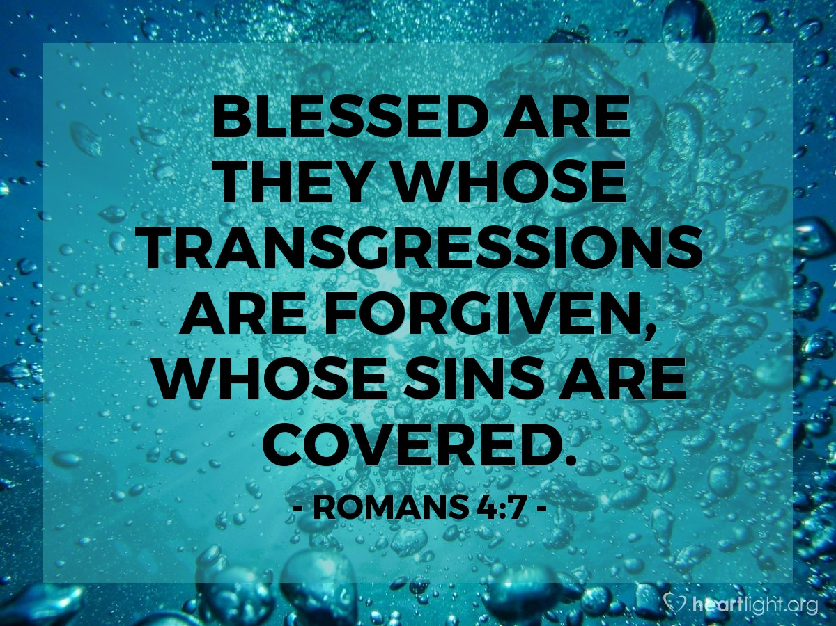
Courtesy of https://www.heartlight.org/
Was Abraham justified by his works? . . . No.  Rom 4:1 AKJV/PCE What shall we say then that Abraham our father, as pertaining to the flesh, hath found?  Rom 4:2 AKJV/PCE For if Abraham were justified by works, he hath whereof to glory; but not before God.  Rom 4:3 AKJV/PCE For what saith the scripture? Abraham believed God, and it was counted unto him for righteousness.  Rom 4:4 AKJV/PCE Now to him that worketh is the reward not reckoned of grace, but of debt.  Rom 4:5 AKJV/PCE But to him that worketh not, but believeth on him that justifieth the ungodly, his faith is counted for righteousness.  Rom 4:6 AKJV/PCE Even as David also describeth the blessedness of the man, unto whom God imputeth righteousness without works,  Rom 4:7 AKJV/PCE Saying, Blessed are they whose iniquities are forgiven, and whose sins are covered.  Rom 4:8 AKJV/PCE Blessed is the man to whom the Lord will not impute sin.  What about our father - our ancestor - Abraham? If he is justified before God by his works then he has a right to Brag!!  But the scriptures say that Abraham believed (trusted) God, and God counted Abraham as righteous because of that!  Gen 15:6 AKJV/PCE And he believed in the LORD; and he counted it to him for righteousness.  Paul is talking here about the difference between getting paid for work you have done verses being given something graciously and freely like a gift.  This is an important difference.  If someone did the work then the employer has the debt to pay the employee.  He has to pay him!  He owes this payment to the employee.  But as with we Christian – we can't do any work that can earn us a declaration of righteousness from God!  We are by nature ungodly (irreverent wicked).  But we have placed faith (trust) in God the Father that He will justify us (regard as righteous).  And the Father counts that faith of ours for righteousness!!  Paul is quoting from Psalm 32:1-2.  https://www.easyenglish.bible/psalms/psalm032-taw.htm#  “David probably wrote Psalm 32 after he had slept with Bathsheba. She was the wife of Uriah. David sent Uriah to die in battle. The David married Bathsheba. For a while he did not ask God to forgive him. As a result he was very unhappy. Then he told God that he was sorry. God forgave him. David became happy again. . . “.  Paul is using this Psalm to show that we are blessed when God considers us righteous even though we can't earn it.  Our sins are forgiven (sent away), they are covered (concealed, forgiven) and God doesn't impute (count them) against us.  God called Abraham righteous while he was still uncircumcised.  Rom 4:9 AKJV/PCE Cometh this blessedness then upon the circumcision only, or upon the uncircumcision also? for we say that faith was reckoned to Abraham for righteousness.  Rom 4:10 AKJV/PCE How was it then reckoned? when he was in circumcision, or in uncircumcision? Not in circumcision, but in uncircumcision.  Rom 4:11 AKJV/PCE And he received the sign of circumcision, a seal of the righteousness of the faith which he had yet being uncircumcised: that he might be the father of all them that believe, though they be not circumcised; that righteousness might be imputed unto them also:  Rom 4:12 AKJV/PCE And the father of circumcision to them who are not of the circumcision only, but who also walk in the steps of that faith of our father Abraham, which he had being yet uncircumcised.  Rom 4:13 AKJV/PCE For the promise, that he should be the heir of the world, was not to Abraham, or to his seed, through the law, but through the righteousness of faith.  Rom 4:14 AKJV/PCE For if they which are of the law be heirs, faith is made void, and the promise made of none effect:  Rom 4:15 AKJV/PCE Because the law worketh wrath: for where no law is, there is no transgression.  Does this blessing of being declared righteous come only to the circumcised?  As Paul points out – Abraham's faith was counted as righteousness.  QUESTION – When was Abraham declared righteous by God?  When he was circumcised? Or still uncircumcised??  NOTE – As Paul points out Abraham was still uncircumcised when God declared him righteous. See Genesis 15:6.  Gen 15:1 AKJV/PCE After these things the word of the LORD came unto Abram in a vision, saying, Fear not, Abram: I am thy shield, and thy exceeding great reward.  Gen 15:2 AKJV/PCE And Abram said, Lord GOD, what wilt thou give me, seeing I go childless, and the steward of my house is this Eliezer of Damascus?  Gen 15:3 AKJV/PCE And Abram said, Behold, to me thou hast given no seed: and, lo, one born in my house is mine heir.  Gen 15:4 AKJV/PCE And, behold, the word of the LORD came unto him, saying, This shall not be thine heir; but he that shall come forth out of thine own bowels shall be thine heir.  Gen 15:5 AKJV/PCE And he brought him forth abroad, and said, Look now toward heaven, and tell the stars, if thou be able to number them: and he said unto him, So shall thy seed be.  Gen 15:6 AKJV/PCE And he believed in the LORD; and he counted it to him for righteousness.  Further, Paul says that Abraham received circumcision as a seal (a signet) of the righteousness through his faith that he had already received while uncircumcised.  This allows Abraham to be the Father of all of us who believe though uncircumcised and of those who are circumcised and also follow in the steps of Abraham's faith.  Gen 17:10 AKJV/PCE This is my covenant, which ye shall keep, between me and you and thy seed after thee; Every man child among you shall be circumcised.  Gen 17:11 AKJV/PCE And ye shall circumcise the flesh of your foreskin; and it shall be a token of the covenant betwixt me and you.  NOTICE – That God declared Abraham righteous in Genesis 15:6. And God gave Abraham the circumcision as a sign of his faith in Genesis 17:10-11 years after he was declared righteous because of his faith.  UNDERSTAND – That God's promise to Abraham (and his descendants) that he should inherit the world wasn't given through the law but through righteousness by faith.  NOTICE – That now Paul says an incredible thing -  If those of the law are heirs then faith is void (made empty) and the promise to Abraham has no effect (it's entirely idle).  Further – Paul says that the Law works (accomplishes) wrath (violent abhorrence, punishment).  Where there is no law there is transgression (violation).  God's plan is that our righteousness is through faith!  Rom 4:16 AKJV/PCE Therefore it is of faith, that it might be by grace; to the end the promise might be sure to all the seed; not to that only which is of the law, but to that also which is of the faith of Abraham; who is the father of us all,  Rom 4:17 AKJV/PCE (As it is written, I have made thee a father of many nations,) before him whom he believed, even God, who quickeneth the dead, and calleth those things which be not as though they were.  Rom 4:18 AKJV/PCE Who against hope believed in hope, that he might become the father of many nations; according to that which was spoken, So shall thy seed be.  Rom 4:19 AKJV/PCE And being not weak in faith, he considered not his own body now dead, when he was about an hundred years old, neither yet the deadness of Sara's womb:  Rom 4:20 AKJV/PCE He staggered not at the promise of God through unbelief; but was strong in faith, giving glory to God;  Rom 4:21 AKJV/PCE And being fully persuaded that, what he had promised, he was able also to perform.  Rom 4:22 AKJV/PCE And therefore it was imputed to him for righteousness.  Paul has concluded above that the Law just gets us wrath – God's rage against us because of our sins.  No one can keep all of that law!  Acts 15:10 AKJV/PCE Now therefore why tempt ye God, to put a yoke upon the neck of the disciples, which neither our fathers nor we were able to bear?  So God's Plan for us is Salvation through God's Graciousness.  Then God's Promise is to all the seed descendants – both those from the law and those entering in faith like Abraham did. In that sense he is the Father of all of us.  God did promise Abraham that he would be the Father of many nations.  Gen 17:5 AKJV/PCE Neither shall thy name any more be called Abram, but thy name shall be Abraham; for a father of many nations have I made thee.  Abraham's situation seemed completely hopeless since he and Sarah his wife were both so old. They were well past child bearing age.  Despite that seeming hopelessness Abraham hoped (he had an expectation) that he would become the father of many nations!  Gen 15:5 AKJV/PCE And he brought him forth abroad, and said, Look now toward heaven, and tell the stars, if thou be able to number them: and he said unto him, So shall thy seed be.  Gen 17:5 AKJV/PCE Neither shall thy name any more be called Abram, but thy name shall be Abraham; for a father of many nations have I made thee.  Abraham's faith wasn't feeble. He considered that his body though 100 years old was not dead! Neither was Sarah's womb dead!  Abraham didn't stagger at God's promise (separate from God in unbelief). Rather Paul says that he was strong (empowered) in his faith and gave God praise.  THINK – This faith of Abraham's was determined, and continuing in the face of what seemed impossible.  Paul is giving us an example here of how we must hang on in faith even when it seems the situation is already lost.  That is probably the hardest thing you will ever do!  Paul says that Abraham was fully convinced (completely assured) that God was able to do what He had promised Abraham!  That is why God counted Abraham's faith as righteousness!  Rom 4:22 ISV This is why “it was credited to him as righteousness.”  We also are righteous through our faith!  Rom 4:23 AKJV/PCE Now it was not written for his sake alone, that it was imputed to him;  Rom 4:24 AKJV/PCE But for us also, to whom it shall be imputed, if we believe on him that raised up Jesus our Lord from the dead;  Rom 4:25 AKJV/PCE Who was delivered for our offences, and was raised again for our justification.  Abraham was declared righteous by God because he believed what God promised even though it looked absolutely impossible!  We see this here in Romans 4 and in Genesis 15:6.  This record isn't in the Bible just for Abraham.  It is there for we Christians to see and believe like Abraham did.  THOUGHT - The Psalmist writes in Psalm 102:18 about future generation reading about God's works and praising Him.  Ps 102:18 AKJV/PCE This shall be written for the generation to come: and the people which shall be created shall praise the LORD.  UNDERSTAND – Abraham believed that even though he and Sarai were very old – to old to have children – that God would do as He was promising and He would give them the son of promise that they hoped for.  We believe in God the Father who resurrected Jesus from the dead.  Jesus died for our offenses (a trespass, transgression) and He was raised for our justification (aquittal).  Rom 4:25 ISV He was sentenced to death because of our sins and raised to life to justify us. | ¿Fue Abraham justificado por sus obras? . . . No.  Rom 4:1 RVG10 ¿Qué, pues, diremos que halló Abraham, nuestro padre según la carne?  Rom 4:2 RVG10 Porque si Abraham fue justificado por las obras, tiene de qué gloriarse; pero no delante de Dios.  Rom 4:3 RVG10 Pues ¿qué dice la Escritura? Creyó Abraham a Dios, y le fue contado por justicia.  Rom 4:4 RVG10 Ahora bien, al que obra no se le cuenta el salario como gracia, sino como deuda.  Rom 4:5 RVG10 Pero al que no obra, pero cree en Aquél que justifica al impío, su fe le es contada por justicia.  Rom 4:6 RVG10 Como David también describe la bienaventuranza del hombre a quien Dios atribuye justicia sin las obras,  Rom 4:7 RVG10 diciendo: Bienaventurados aquellos cuyas iniquidades son perdonadas, y cuyos pecados son cubiertos.  Rom 4:8 RVG10 Bienaventurado el varón a quien el Señor no imputará pecado.  ¿Qué hay de nuestro padre, nuestro antepasado, Abraham? ¡Si está justificado ante Dios por sus obras, entonces tiene derecho a fanfarronear!  ¡Pero las escrituras dicen que Abraham creyó (confió) en Dios, y Dios contó a Abraham como justo por eso!  Gen 15:6 RVG10 Y creyó a Jehová, y Él se lo contó por justicia.  Pablo está hablando aquí de la diferencia entre recibir un pago por el trabajo que has hecho y recibir algo con gracia y gratuitamente como un regalo.  Esta es una diferencia importante.  Si alguien hizo el trabajo, entonces el empleador tiene la deuda de pagar al empleado.  ¡Tiene que pagarle!  Le debe este pago al empleado.  Pero al igual que con nosotros cristianos, ¡no podemos hacer ningún trabajo que nos gane una declaración de justicia de Dios!  Somos por naturaleza impíos (malvados irreverentes).  Pero hemos puesto la fe (confianza) en Dios el Padre que Él nos justificará (tener por justos).  ¡¡Y el Padre cuenta esa fe nuestra por justicia!!  Pablo está citando el Salmo 32:1-2.  https://www.easyenglish.bible/psalms/psalm032-taw.htm#  “David probablemente escribió el Salmo 32 después de haberse acostado con Betsabé. Ella era la esposa de Urías. David envió a Urías a morir en la batalla. El David se casó con Betsabé. Durante un tiempo no le pidió a Dios que lo perdonara. Como resultado, estaba muy infeliz. Entonces le dijo a Dios que lo sentía. Dios lo perdonó. David volvió a ser feliz. . . “.  Pablo está usando este Salmo para mostrar que somos bendecidos cuando Dios nos considera justos aunque no podamos ganárnoslo.  Nuestros pecados son perdonados (despedidos), están cubiertos (ocultos, perdonados) y Dios no los imputa (los cuenta) contra nosotros.  Dios llamó a Abraham justo cuando aún no estaba circuncidado.  Rom 4:9 RVG10 ¿Es, pues, esta bienaventuranza solamente para los de la circuncisión, o también para los de la incircuncisión? Porque decimos que a Abraham le fue contada la fe por justicia.  Rom 4:10 RVG10 ¿Cómo, pues, le fue contada? ¿Estando él en la circuncisión, o en la incircuncisión? No en la circuncisión, sino en la incircuncisión.  Rom 4:11 RVG10 Y recibió la señal de la circuncisión, el sello de la justicia de la fe que tuvo siendo aún incircunciso; para que fuese padre de todos los creyentes no circuncidados; a fin de que también a ellos les sea imputada la justicia;  Rom 4:12 RVG10 y padre de la circuncisión, a los que son, no sólo de la circuncisión sino que también siguen las pisadas de la fe que tuvo nuestro padre Abraham antes de ser circuncidado.  Rom 4:13 RVG10 Porque la promesa de que él sería heredero del mundo, no fue dada a Abraham o a su simiente por la ley, sino por la justicia de la fe.  Rom 4:14 RVG10 Porque si los que son de la ley son los herederos, vana es la fe, y anulada es la promesa.  Rom 4:15 RVG10 Porque la ley produce ira; pero donde no hay ley, tampoco hay transgresión.  ¿Esta bendición de ser declarados justos llega solo a los circuncidados?  Como señala Pablo, la fe de Abraham fue contada por justicia.  PREGUNTA – ¿Cuándo fue Abraham declarado justo por Dios?  Cuando estaba circuncidado? ¿O aún no está circuncidado?  NOTA – Como señala Pablo, Abraham aún no estaba circuncidado cuando Dios lo declaró justo. Véase Génesis 15:6.  Gen 15:1 RVG10 Después de estas cosas vino la palabra de Jehová a Abram en visión, diciendo: No temas, Abram; yo soy tu escudo, y soy tu galardón sobremanera grande.  Gen 15:2 RVG10 Y respondió Abram: Señor Jehová ¿qué me has de dar, siendo así que ando sin hijos, y el mayordomo de mi casa es ese damasceno Eliezer?  Gen 15:3 RVG10 Dijo más Abram: Mira que no me has dado hijos, y he aquí que es mi heredero uno nacido en mi casa.  Gen 15:4 RVG10 Y luego vino a él la palabra de Jehová, diciendo: No te heredará éste, sino el que saldrá de tus entrañas será el que te herede.  Gen 15:5 RVG10 Y le llevó fuera, y dijo: Mira ahora a los cielos, y cuenta las estrellas, si las puedes contar. Y le dijo: Así será tu simiente.  Gen 15:6 RVG10 Y creyó a Jehová, y Él se lo contó por justicia.  Además, Pablo dice que Abraham recibió la circuncisión como un sello (un sello) de la justicia a través de su fe que ya había recibido mientras estaba incircunciso.  Esto le permite a Abraham ser el Padre de todos los que creemos aunque no estamos circuncidados y de los que somos circuncisos y también seguimos las huellas de la fe de Abraham.  Gen 17:10 RVG10 Éste es mi pacto, que guardaréis entre mí y vosotros y tu simiente después de ti: Será circuncidado todo varón de entre vosotros.  Gen 17:11 RVG10 Circuncidaréis, pues, la carne de vuestro prepucio, y será por señal del pacto entre mí y vosotros.  AVISO – Que Dios declaró justo a Abraham en Génesis 15:6. Y Dios le dio a Abraham la circuncisión como señal de su fe en Génesis 17:10-11 años después de que fue declarado justo por su fe.  ENTIENDE – Que la promesa de Dios a Abraham (ya sus descendientes) de que heredaría el mundo no fue dada por la ley sino por la justicia por la fe.  AVISO – Que ahora Paul dice algo increíble –  Si los de la ley son herederos, entonces la fe es vana (se vacía) y la promesa a Abraham no tiene efecto (es completamente ociosa).  Además, Pablo dice que la Ley obra (cumple) la ira (aborrecimiento violento, castigo).  Donde no hay ley hay transgresión (violación).  God's plan is that our righteousness is through faith!  Rom 4:16 RVG10 Por tanto, es por la fe, para que sea por gracia; a fin de que la promesa sea firme a toda simiente; no sólo al que es de la ley, sino también al que es de la fe de Abraham, quien es el padre de todos nosotros  Rom 4:17 RVG10 (como está escrito: Padre de muchas naciones, te he hecho) delante de Dios, a quien creyó; el cual da vida a los muertos, y llama las cosas que no son, como si fuesen.  Rom 4:18 RVG10 El cual creyó en esperanza contra esperanza, para venir a ser padre de muchas naciones, conforme a lo que le había sido dicho: Así será tu simiente.  Rom 4:19 RVG10 Y no se debilitó en la fe, ni consideró su cuerpo ya muerto (siendo ya como de cien años), ni la matriz muerta de Sara.  Rom 4:20 RVG10 Tampoco dudó, por incredulidad, de la promesa de Dios, sino que se fortaleció en fe, dando gloria a Dios,  Rom 4:21 RVG10 plenamente convencido que todo lo que Él había prometido, era también poderoso para hacerlo;  Rom 4:22 RVG10 por lo cual también le fue imputado por justicia.  Pablo ha concluido anteriormente que la Ley simplemente nos provoca la ira, la ira de Dios contra nosotros a causa de nuestros pecados. ¡Nadie puede guardar toda esa ley!  Acts 15:10 RVG10 Ahora, pues, ¿por qué tentáis a Dios, poniendo sobre la cerviz de los discípulos un yugo que ni nuestros padres ni nosotros hemos podido llevar?  Así que el Plan de Dios para nosotros es la Salvación a través de la Gracia de Dios.  Entonces la Promesa de Dios es para todos los descendientes de la simiente – tanto los de la ley como los que entraron en la fe como lo hizo Abraham. En ese sentido, él es el Padre de todos nosotros.  Dios le prometió a Abraham que sería el Padre de muchas naciones.  Gen 17:5 RVG10 Gen 17:5 RVG10 Y no se llamará más tu nombre Abram, sino que será tu nombre Abraham, porque te he puesto por padre de muchedumbre de gentes.  La situación de Abraham parecía completamente desesperada ya que tanto él como Sara, su esposa, eran muy viejos. Estaban mucho más allá de la edad de procrear.  ¡A pesar de esa aparente desesperanza, Abraham esperaba (tenía una expectativa) que se convertiría en el padre de muchas naciones!  Gen 15:5 RVG10 Y le llevó fuera, y dijo: Mira ahora a los cielos, y cuenta las estrellas, si las puedes contar. Y le dijo: Así será tu simiente.  Gen 17:5 RVG10 Y no se llamará más tu nombre Abram, sino que será tu nombre Abraham, porque te he puesto por padre de muchedumbre de gentes.  La fe de Abraham no fue débil. ¡Él consideró que su cuerpo aunque tenía 100 años no estaba muerto! ¡Tampoco la matriz de Sara estaba muerta!  Abraham no titubeó ante la promesa de Dios (se separó de Dios en incredulidad). Más bien, Pablo dice que era fuerte (poderoso) en su fe y alababa a Dios.  PENSAR – Esta fe de Abraham fue decidida y continua frente a lo que parecía imposible.  Pablo nos está dando un ejemplo aquí de cómo debemos aferrarnos a la fe incluso cuando parece que la situación ya está perdida.  ¡Esa es probablemente la cosa más difícil que jamás harás!  Pablo dice que Abraham estaba completamente convencido (completamente seguro) de que Dios podía hacer lo que le había prometido a Abraham.  ¡Por eso Dios contó la fe de Abraham por justicia!  Rom 4:22 NBLA Por lo cual también su fe le fue contada por justicia.  ¡Nosotros también somos justos por nuestra fe!  Rom 4:23 RVG10 Y que le fue imputado, no fue escrito solamente por causa de él,  Rom 4:24 RVG10 sino también por nosotros, a quienes será imputado, esto es, a los que creemos en el que levantó de los muertos a Jesús nuestro Señor;  Rom 4:25 RVG10 el cual fue entregado por nuestras transgresiones, y resucitado para nuestra justificación.  Abraham fue declarado justo por Dios porque creyó lo que Dios prometió, ¡aunque parecía absolutamente imposible!  Vemos esto aquí en Romanos 4 y en Génesis 15:6.  Este registro no está en la Biblia solo para Abraham.  Está ahí para que los cristianos veamos y creamos como lo hizo Abraham.  PENSAMIENTO - El Salmista escribe en el Salmo 102:18 acerca de la lectura de las generaciones futuras acerca de las obras de Dios y alabarlo.  Ps 102:18 RVG10 Se escribirá esto para la generación venidera; y el pueblo que será creado, alabará a JAH.  ENTIENDE – Abraham creyó que aunque él y Sarai eran muy viejos – demasiado viejos para tener hijos – que Dios haría lo que prometía y les daría el hijo de la promesa que ellos esperaban.  Creemos en Dios Padre que resucitó a Jesús de entre los muertos.  Jesús murió por nuestras ofensas (una transgresión, una transgresión) y resucitó para nuestra justificación (absolución).  Rom 4:25 NBV Él murió por nuestros pecados y resucitó para poder presentarnos justos ante Dios.

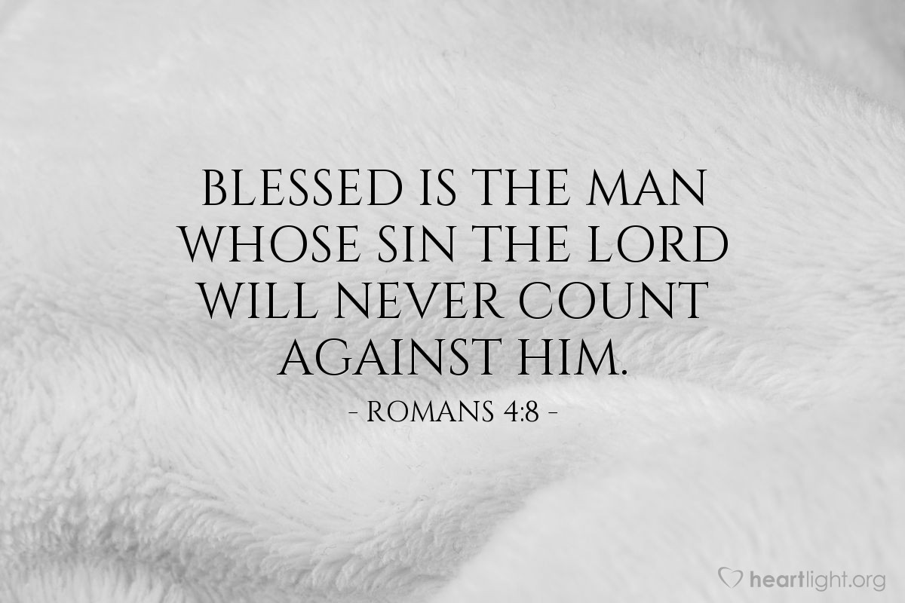
Courtesy of https://www.heartlight.org/

