Romans 3 We're justified by faith without the works of the law ES
Romanos 3 Somos justificados por fe sin las obras de la ley ES

Lesson developed by John M. Wharton March 15, 2023
http://www.biblestudyadventures.com/
Sources -
From theWord Bible program http://www.theword.net/ . Generally King James Version.
Greek, Hebrew definitions Mickelson's Enhanced Strong's, Brown-Driver-Briggs', Thayer's generally.

In Romans 3, Paul talked a great deal in Romans 2 about the hypocrisy of some Jewish people.  So here he looks at the other perspective and shows that they have a very important position.  God gave the Jewish people the Old Testament to safe guard and copy so that later generations would have God's Word.  Paul also shows from scriptures in the Old Testament that there were many of Israel who had the Law of Moses yet still lived sinful, rebellious lives with no love or concern for God.  Paul's conclusion is that the Law served the purpose of shopwing the people what was sin. But God did not put any power in the Law to keep people from sin. | En Romanos 3, Pablo habló mucho en Romanos 2 sobre la hipocresía de algunos judíos.  Así que aquí mira la otra perspectiva y muestra que tienen una posición muy importante.  Dios le dio al pueblo judío el Antiguo Testamento para que lo guardaran y copiaran para que las generaciones posteriores tuvieran la Palabra de Dios.  Pablo también muestra a partir de las escrituras del Antiguo Testamento que había muchos en Israel que tenían la Ley de Moisés y aún así vivían vidas pecaminosas y rebeldes sin amor ni preocupación por Dios.  La conclusión de Pablo es que la Ley cumplió el propósito de mostrarle a la gente lo que era pecado. Pero la Ley no quitó el pecado.

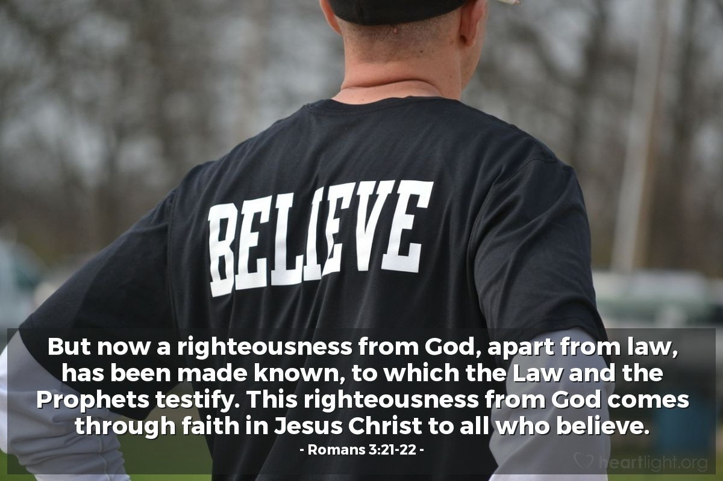
Courtesy of https://www.heartlight.org/
God is Faithful - Believe it or Not!!  Rom 3:1 AKJV/PCE What advantage then hath the Jew? or what profit is there of circumcision?  Rom 3:2 AKJV/PCE Much every way: chiefly, because that unto them were committed the oracles of God.  Rom 3:3 AKJV/PCE For what if some did not believe? shall their unbelief make the faith of God without effect?  Rom 3:4 AKJV/PCE God forbid: yea, let God be true, but every man a liar; as it is written, That thou mightest be justified in thy sayings, and mightest overcome when thou art judged.  Rom 3:5 AKJV/PCE But if our unrighteousness commend the righteousness of God, what shall we say? Is God unrighteous who taketh vengeance? (I speak as a man)  Rom 3:6 AKJV/PCE God forbid: for then how shall God judge the world?  Rom 3:7 AKJV/PCE For if the truth of God hath more abounded through my lie unto his glory; why yet am I also judged as a sinner?  Rom 3:8 AKJV/PCE And not rather, (as we be slanderously reported, and as some affirm that we say,) Let us do evil, that good may come? whose damnation is just.  UNDERSTAND THIS - Paul has shown in Romans 1-2 that early man did know about God. They could see His tendency to love and provide for us in this creation. But they still left God and went to idols!  Knowledge itself won't save you.  And Paul showed us that even among the Jewish people – his own people – there was far to much hypocrisy! Judging others all the time and then doing the very same sins!  The Law did show them what was sin . . . but God was not delivering them from sin through the Law.  That would come through forgiveness and grace.  IMPORTANT POINT - The position of the Jewish people is important.  Paul does not mean that they have no significance.  God gave the keeping of His scriptures to the Jewish people!  But some did not believe in God or respect Him.  Does their unbelief make God's faithfulness non existing??  Absolutely not! Paul tells us that God does really exist.  Let all the world lie all they want! But God's Word is righteous!  And He will judge and subdue all those whom He judges!  After his affair with Bathsheba King David felt compelled to pray this to God -  Psalm 51:4 NIV Against you, you only, have I sinned  and done what is evil in your sight;  so you are right in your verdict  and justified when you judge.  THINK ABOUT THIS - God's righteousness is really highlighted when He forgives us of our sin. So some have thought that God is unrighteous for inflicting His wrath on us.  But that can't be true. God has to judge this world and the evil in it!  Some even claimed that Paul had said that we should do evil = bad things so that the good of God's forgiveness can really be seen!  Paul says that the damnation, condemnation of these people is just, right.  Romans 3:8 GOD'S WORD® Translation  . . . They are condemned, and that's what they deserve.  Jews and Gentiles – Both are under the control of sin!  Rom 3:9 AKJV/PCE What then? are we better than they? No, in no wise: for we have before proved both Jews and Gentiles, that they are all under sin;  Rom 3:10 AKJV/PCE As it is written, There is none righteous, no, not one:  Rom 3:11 AKJV/PCE There is none that understandeth, there is none that seeketh after God.  Rom 3:12 AKJV/PCE They are all gone out of the way, they are together become unprofitable; there is none that doeth good, no, not one.  Rom 3:13 AKJV/PCE Their throat is an open sepulchre; with their tongues they have used deceit; the poison of asps is under their lips:  Rom 3:14 AKJV/PCE Whose mouth is full of cursing and bitterness:  Rom 3:15 AKJV/PCE Their feet are swift to shed blood:  Rom 3:16 AKJV/PCE Destruction and misery are in their ways:  Rom 3:17 AKJV/PCE And the way of peace have they not known:  Rom 3:18 AKJV/PCE There is no fear of God before their eyes.  Now Paul is showing us that we Gentiles aren't better than the Jewish people. We all – both Gentiles and Jews – are under the power of sin. None of us can get away from sin completely.  Gal 3:21 AKJV/PCE Is the law then against the promises of God? God forbid: for if there had been a law given which could have given life, verily righteousness should have been by the law.  Gal 3:22 AKJV/PCE But the scripture hath concluded all under sin, that the promise by faith of Jesus Christ might be given to them that believe.  Paul quotes from several Old Testament verses to show that this is true.  He especially uses verses from the Psalms written by King David to show what the writers have been shown about man's sinful tendencies.  NOTICE THAT – These writers in the Old Testament context also realized just how much all people are under sin!  To sum up what these verses say -  No one is truly righteous on their own!  They don't really understand God or try to find Him.  Many look for more ways to sin more!  They search hard for it!!  They are like dead people with poison like snakes!  Bitter and cursing. Killing for no reason! Murder!  No peace in them at all!  And no fear at all of God!!  That is a Damning Indictment of man and woman in their sins!  Here are the Old Testament verses Paul used -  Ps 14:1 AKJV/PCE To the chief Musician, A Psalm of David. The fool hath said in his heart, There is no God. They are corrupt, they have done abominable works, there is none that doeth good.  Ps 14:2 AKJV/PCE The LORD looked down from heaven upon the children of men, to see if there were any that did understand, and seek God.  Ps 14:3 AKJV/PCE They are all gone aside, they are all together become filthy: there is none that doeth good, no, not one.  Ps 53:1 AKJV/PCE To the chief Musician upon Mahalath, Maschil, A Psalm of David. The fool hath said in his heart, There is no God. Corrupt are they, and have done abominable iniquity: there is none that doeth good.  Ps 53:2 AKJV/PCE God looked down from heaven upon the children of men, to see if there were any that did understand, that did seek God.  Ps 53:3 AKJV/PCE Every one of them is gone back: they are altogether become filthy; there is none that doeth good, no, not one.  Ps 5:9 AKJV/PCE For there is no faithfulness in their mouth; their inward part is very wickedness; their throat is an open sepulchre; they flatter with their tongue.  Ps 140:3 AKJV/PCE They have sharpened their tongues like a serpent; adders' poison is under their lips. Selah.  Ps 10:7 AKJV/PCE His mouth is full of cursing and deceit and fraud: under his tongue is mischief and vanity.  Isa 59:7 AKJV/PCE Their feet run to evil, and they make haste to shed innocent blood: their thoughts are thoughts of iniquity; wasting and destruction are in their paths.  Isa 59:8 AKJV/PCE The way of peace they know not; and there is no judgment in their goings: they have made them crooked paths: whosoever goeth therein shall not know peace.  Ps 36:1 AKJV/PCE To the chief Musician, A Psalm of David the servant of the LORD. The transgression of the wicked saith within my heart, that there is no fear of God before his eyes.  The weight of sin is overwhelming.  Everyone of us has that warped nature within us.  And we cannot free ourselves from sin.  Some are clearly much worse in the manner of their lives.  But we all have sinned willingly.  THE POINT IS THAT - Paul is moving us to the realization that we all have to have help from God.  We need saving from those sins.  The Law only showed you what was sin!  Rom 3:19 AKJV/PCE Now we know that what things soever the law saith, it saith to them who are under the law: that every mouth may be stopped, and all the world may become guilty before God.  Rom 3:20 AKJV/PCE Therefore by the deeds of the law there shall no flesh be justified in his sight: for by the law is the knowledge of sin.  Rom 3:21 AKJV/PCE But now the righteousness of God without the law is manifested, being witnessed by the law and the prophets;  Rom 3:22 AKJV/PCE Even the righteousness of God which is by faith of Jesus Christ unto all and upon all them that believe: for there is no difference:  Rom 3:23 AKJV/PCE For all have sinned, and come short of the glory of God;  Rom 3:24 AKJV/PCE Being justified freely by his grace through the redemption that is in Christ Jesus:  Rom 3:25 AKJV/PCE Whom God hath set forth to be a propitiation through faith in his blood, to declare his righteousness for the remission of sins that are past, through the forbearance of God;  Rom 3:26 AKJV/PCE To declare, I say, at this time his righteousness: that he might be just, and the justifier of him which believeth in Jesus.  Rom 3:27 AKJV/PCE Where is boasting then? It is excluded. By what law? of works? Nay: but by the law of faith.  The Mosaic Law was given for the people of Israel to live by.  When God gave the Law THEN they knew what was sin.  Then they were guilty (1. under sentence 2. (by implication) condemned) of their sins.  They couldn't plead innocence.  Paul says clearly that “through the law comes knowledge of sin” (ESV2011).  The Law did not bring salvation from sin the way that Jesus sacrifice has.  It showed the people what was sinful and they had to do their best to stop doing those things.  And there were sacrifices to cover their failures!  IMPORTANT – God had the Plan to give righteousness without the law even in the Old Testament. But it was not time for it.  The Law and the Prophets both did say that this would happen.  Gen 3:15 AKJV/PCE And I will put enmity between thee and the woman, and between thy seed and her seed; it shall bruise thy head, and thou shalt bruise his heel.  Dan 9:24 AKJV/PCE Seventy weeks are determined upon thy people and upon thy holy city, to finish the transgression, and to make an end of sins, and to make reconciliation for iniquity, and to bring in everlasting righteousness, and to seal up the vision and prophecy, and to anoint the most Holy.  Dan 9:25 AKJV/PCE Know therefore and understand, that from the going forth of the commandment to restore and to build Jerusalem unto the Messiah the Prince shall be seven weeks, and threescore and two weeks: the street shall be built again, and the wall, even in troublous times.  Dan 9:26 AKJV/PCE And after threescore and two weeks shall Messiah be cut off, but not for himself: and the people of the prince that shall come shall destroy the city and the sanctuary; and the end thereof shall be with a flood, and unto the end of the war desolations are determined.  Isa 53:4 AKJV/PCE ¶ Surely he hath borne our griefs, and carried our sorrows: yet we did esteem him stricken, smitten of God, and afflicted.  Isa 53:5 AKJV/PCE But he was wounded for our transgressions, he was bruised for our iniquities: the chastisement of our peace was upon him; and with his stripes we are healed.  Isa 53:6 AKJV/PCE All we like sheep have gone astray; we have turned every one to his own way; and the LORD hath laid on him the iniquity of us all.  Now Paul has shown that we are all sinful.  But the Father has accepted Jesus sacrifice for sins.  And He the Father has provided that all who ask Him for forgiveness by faith (trust, confidence in God to forgive us) in Jesus sacrifice will righteous!  The Father will freely and graciously justify us (regard us as righteous) through the redemption Jesus has provided (He has paid our ransom from sin in FULL)!  If we will put out to the Father that faith (trust, confidence in God to forgive us) in Jesus blood then the Father places as a propitiation for our sins.  Propitiation is the act of gaining the favor of or making things right with someone, especially after having done something wrong (DICTIONARY.COM).  God rightly justly passes over – He forgives our past sins.  So no one has any right to boast as being just before God because of religious works that they have done.  The only righteousness that we can have is through faith in the Father's forgiveness through Jesus sacrifice for sins.  We are justified by Faith without the works of the Law!!  Rom 3:28 AKJV/PCE Therefore we conclude that a man is justified by faith without the deeds of the law.  Rom 3:29 AKJV/PCE Is he the God of the Jews only? is he not also of the Gentiles? Yes, of the Gentiles also:  Rom 3:30 AKJV/PCE Seeing it is one God, which shall justify the circumcision by faith, and uncircumcision through faith.  Rom 3:31 AKJV/PCE Do we then make void the law through faith? God forbid: yea, we establish the law.  Paul sums up this chapter by showing that we can see that no one is justified by the works of the Law.  Rather we are justified before God by Faith in Jesus sacrifice for sins.  Further – God is One. He is the true God.  And God is concerned about all of us.  He has provided Salvation for both the Jewish people and the Gentiles.  Also, we don't make the Law Void because we can be Saved and Justified through Faith in Jesus Sacrifice. | Dios es Fiel - Lo Creas o No!!  Rom 3:1 RVG10 ¿Qué ventaja, pues, tiene el judío? ¿O de qué aprovecha la circuncisión?  Rom 3:2 RVG10 Mucho, en todas maneras. Primero, porque ciertamente a ellos les ha sido confiada la palabra de Dios.  Rom 3:3 RVG10 ¿Y qué si algunos de ellos no han creído? ¿La incredulidad de ellos hará nula la fe de Dios?  Rom 3:4 RVG10 ¡En ninguna manera! Antes bien, sea Dios veraz, y todo hombre mentiroso; como está escrito: Para que seas justificado en tus palabras, y venzas cuando seas juzgado.  Rom 3:5 RVG10 Y si nuestra injusticia encarece la justicia de Dios, ¿qué diremos? ¿Será injusto Dios que da castigo? (Hablo como hombre.)  Rom 3:6 RVG10 ¡En ninguna manera! De otro modo, ¿cómo juzgaría Dios al mundo?  Rom 3:7 RVG10 Pero si por mi mentira la verdad de Dios abundó para su gloria, ¿por qué aún soy juzgado como pecador?  Rom 3:8 RVG10 ¿Y por qué no decir (como somos difamados, y algunos afirman que decimos): Hagamos males para que vengan bienes? La condenación de los cuales es justa.  ENTIENDE ESTO - Pablo ha mostrado en Romanos 1-2 que el hombre primitivo sí sabía acerca de Dios. Pudieron ver Su tendencia a amarnos y proveernos en esta creación. ¡Pero aun así dejaron a Dios y se fueron a los ídolos!  El conocimiento en sí mismo no te salvará.  Y Pablo nos mostró que incluso entre el pueblo judío, su propio pueblo, ¡había demasiada hipocresía! ¡Juzgar a los demás todo el tiempo y luego cometer los mismos pecados!  La Ley les mostró lo que era el pecado. . . pero Dios no los estaba liberando del pecado a través de la Ley.  Eso vendría a través del perdón y la gracia.  PUNTO IMPORTANTE - La posición del pueblo judío es importante.  Pablo no quiere decir que no tengan significado.  ¡Dios le dio la custodia de Sus escrituras al pueblo judío!  Pero algunos no creían en Dios ni lo respetaban.  ¿Su incredulidad hace que la fidelidad de Dios no exista?  ¡Absolutamente no! Pablo nos dice que Dios realmente existe.  ¡Que todo el mundo mienta todo lo que quiera! ¡Pero la Palabra de Dios es justa!  ¡Y Él juzgará y someterá a todos aquellos a quienes Él juzgue!  Después de su aventura con Betsabé, el rey David se sintió obligado a orar esto a Dios:  Salmos 51:4 NVI Contra ti he pecado, solo contra ti,  y he hecho lo que es malo ante tus ojos;  por eso, tu sentencia es justa,  y tu juicio, irreprochable.  PIENSA SOBRE ESTO - La justicia de Dios se destaca realmente cuando nos perdona nuestros pecados. Así que algunos han pensado que Dios es injusto por infligir Su ira sobre nosotros.  Pero eso no puede ser cierto. ¡Dios tiene que juzgar este mundo y el mal que hay en él!  ¡Algunos incluso afirmaron que Pablo había dicho que debemos hacer el mal = cosas malas para que realmente se vea el bien del perdón de Dios!  Pablo dice que la condenación, la condenación de estas personas es justa, correcta.  Romanos 3:8 NTV  . . . Los que dicen tales cosas merecen ser condenados.  Judíos y gentiles – ¡Ambos están bajo el control del pecado!  Rom 3:9 RVG10 ¿Qué, pues? ¿Somos mejores que ellos? En ninguna manera; porque ya hemos acusado a judíos y a gentiles, que todos están bajo pecado.  Rom 3:10 RVG10 Como está escrito: No hay justo, ni aun uno.  Rom 3:11 RVG10 No hay quien entienda, no hay quien busque a Dios.  Rom 3:12 RVG10 Todos se desviaron del camino, a una se hicieron inútiles; no hay quien haga lo bueno, no hay ni siquiera uno.  Rom 3:13 RVG10 Sepulcro abierto es su garganta; con su lengua engañan, veneno de áspides hay debajo de sus labios;  Rom 3:14 RVG10 cuya boca está llena de maldición y de amargura;  Rom 3:15 RVG10 sus pies, prestos para derramar sangre;  Rom 3:16 RVG10 destrucción y miseria hay en sus caminos;  Rom 3:17 RVG10 y el camino de paz no han conocido.  Rom 3:18 RVG10 No hay temor de Dios delante de sus ojos.  Now Paul is showing us that we Gentiles aren't better than the Jewish people. We all – both Gentiles and Jews – are under the power of sin. Ninguno de nosotros puede alejarse completamente del pecado.  Gal 3:21 RVG10 ¿Luego la ley es contraria a las promesas de Dios? ¡En ninguna manera! Porque si se hubiera dado una ley que pudiera vivificar, la justicia verdaderamente habría sido por la ley.  Gal 3:22 RVG10 Mas la Escritura encerró todo bajo pecado, para que la promesa por la fe de Jesucristo, fuese dada a los que creen.  Pablo cita varios versículos del Antiguo Testamento para mostrar que esto es cierto.  Usa especialmente versos de los Salmos escritos por el Rey David para mostrar lo que se les ha mostrado a los escritores acerca de las tendencias pecaminosas del hombre.  TENGA EN CUENTA QUE: ¡Estos escritores del Antiguo Testamento también se dieron cuenta de que todas las personas están bajo el pecado!  Para resumir lo que dicen estos versículos -  ¡nadie es verdaderamente justo por sí mismo!  Realmente no entienden a Dios ni tratan de encontrarlo.  ¡Muchos buscan más formas de pecar más!  Lo buscan mucho!!  ¡Son como muertos con veneno como serpientes!  Amargo y maldiciente. ¡Matar sin razón! ¡Asesinato!  ¡No hay paz en ellos en absoluto!  Y sin temor alguno de Dios!!  ¡Esa es una acusación condenatoria del hombre y la mujer en sus pecados!  Here are the Old Testament verses Paul used -  Ps 14:1 RVG10 «Al Músico principal: Salmo de David» Dijo el necio en su corazón: No hay Dios. Se corrompieron, hicieron obras abominables; no hay quien haga el bien.  Ps 14:2 RVG10 Jehová miró desde los cielos sobre los hijos de los hombres, para ver si había algún entendido, que buscara a Dios.  Ps 14:3 RVG10 Todos se desviaron, a una se han corrompido; no hay quien haga el bien, no hay ni siquiera uno.  Ps 53:1 RVG10 «Al Músico principal: sobre Mahalat: Masquil de David» Dijo el necio en su corazón: No hay Dios. Se corrompieron e hicieron abominable maldad; no hay quien haga el bien.  Ps 53:2 RVG10 Dios desde los cielos miró sobre los hijos de los hombres, para ver si había algún entendido que buscara a Dios.  Ps 53:3 RVG10 Cada uno se había vuelto atrás; todos se habían corrompido; no hay quien haga el bien, no hay ni siquiera uno.  Ps 5:9 RVG10 Porque en su boca no hay rectitud; sus entrañas son perversidad; sepulcro abierto es su garganta; con su lengua lisonjean.  Ps 140:3 RVG10 Aguzaron su lengua como la serpiente; veneno de áspid hay debajo de sus labios. (Selah)  Ps 10:7 RVG10 Su boca está llena de maldición, de engaño y de fraude; debajo de su lengua hay vejación y maldad.  Isa 59:7 RVG10 Sus pies corren al mal, y se apresuran para derramar la sangre inocente; sus pensamientos, son pensamientos de iniquidad, destrucción y quebrantamiento hay en sus caminos.  Isa 59:8 RVG10 No conocen camino de paz, ni hay derecho en sus caminos; sus veredas son torcidas; cualquiera que por ellas fuere, no conocerá paz.  Ps 36:1 RVG10 «Al Músico principal: Salmo de David, siervo del Señor» La iniquidad del impío me dice al corazón: No hay temor de Dios delante de sus ojos.  El peso del pecado es abrumador.  Cada uno de nosotros tiene esa naturaleza retorcida dentro de nosotros.  Y no podemos librarnos del pecado.  Algunos son claramente mucho peores en la forma de sus vidas.  Pero todos hemos pecado voluntariamente.  EL PUNTO ES QUE - Pablo nos está llevando a darnos cuenta de que todos tenemos que tener la ayuda de Dios. Necesitamos salvación de esos pecados.  ¡La Ley solo te mostró lo que era pecado!  Rom 3:19 RVG10 Pero sabemos que todo lo que la ley dice, a los que están bajo la ley lo dice; para que toda boca se tape, y todo el mundo sea hallado culpable delante de Dios.  Rom 3:20 RVG10 Por tanto, por las obras de la ley ninguna carne será justificada delante de Él; pues por la ley es el conocimiento del pecado.  Rom 3:21 RVG10 Mas ahora, aparte de la ley, la justicia de Dios es manifestada, siendo testificada por la ley y los profetas;  Rom 3:22 RVG10 la justicia de Dios que es por la fe de Jesucristo, para todos y sobre todos los que creen; porque no hay diferencia;  Rom 3:23 RVG10 por cuanto todos pecaron, y están destituidos de la gloria de Dios;  Rom 3:24 RVG10 siendo justificados gratuitamente por su gracia mediante la redención que es en Cristo Jesús;  Rom 3:25 RVG10 a quien Dios ha puesto en propiciación por medio de la fe en su sangre, para manifestar su justicia por la remisión de los pecados pasados, en la paciencia de Dios,  Rom 3:26 RVG10 para manifestar su justicia en este tiempo; para que Él sea justo, y el que justifica al que cree en Jesús.  Rom 3:27 RVG10 ¿Dónde, pues, está la jactancia? Queda excluida. ¿Por cuál ley? ¿De las obras? No, sino por la ley de la fe.  La Ley Mosaica fue dada para que el pueblo de Israel la viviera.  Cuando Dios dio la Ley ENTONCES ellos sabían lo que era el pecado.  Entonces eran culpables (1. bajo la oración 2. (por implicación) condenados) de sus pecados.  No podían alegar inocencia.  Pablo dice claramente que “por medio de la ley viene el conocimiento del pecado” (LBLA).  La Ley no trajo la salvación del pecado de la manera que lo hizo el sacrificio de Jesús.  Mostró a la gente lo que era pecaminoso y tenían que hacer todo lo posible para dejar de hacer esas cosas.  ¡Y hubo sacrificios para cubrir sus fracasos!  IMPORTANTE: Dios tenía el plan de dar justicia sin la ley, incluso en el Antiguo Testamento. Pero no era el momento para eso.  Tanto la Ley como los Profetas dijeron que esto sucedería.  Gen 3:15 RVG10 Y pondré enemistad entre ti y la mujer, y entre tu simiente y su simiente; Él te herirá en la cabeza, y tú le herirás en el calcañar.  Dan 9:24 RVG10 Setenta semanas están determinadas sobre tu pueblo y sobre tu santa ciudad, para acabar la prevaricación, y concluir el pecado, y expiar la iniquidad; y para traer la justicia eterna, y sellar la visión y la profecía, y ungir al Santo de los santos.  Dan 9:25 RVG10 Sabe, pues, y entiende, que desde la salida de la orden para restaurar y edificar a Jerusalén hasta el Mesías Príncipe, habrá siete semanas, y sesenta y dos semanas; la plaza volverá a ser edificada, y el muro, en tiempos angustiosos.  Dan 9:26 RVG10 Y después de las sesenta y dos semanas se quitará la vida al Mesías, mas no por sí; y el pueblo del príncipe que ha de venir, destruirá la ciudad y el santuario; con inundación será el fin de ella, y hasta el fin de la guerra las asolaciones están determinadas.  Isa 53:4 RVG10 Ciertamente llevó Él nuestras enfermedades, y sufrió nuestros dolores; y nosotros le tuvimos por azotado, por herido de Dios y abatido.  Isa 53:5 RVG10 Mas Él herido fue por nuestras transgresiones, molido por nuestros pecados; el castigo de nuestra paz fue sobre Él, y por su llaga fuimos nosotros curados.  Isa 53:6 RVG10 Todos nosotros nos descarriamos como ovejas, cada cual se apartó por su camino; mas Jehová cargó en Él el pecado de todos nosotros.  Ahora Pablo ha mostrado que todos somos pecadores.  Pero el Padre ha aceptado el sacrificio de Jesús por los pecados.  ¡Y Él, el Padre, ha dispuesto que todos los que le pidan perdón por la fe (confianza, confianza en Dios para que nos perdone) en Jesús se sacrifiquen justos!  ¡El Padre nos justificará libre y generosamente (nos considerará justos) a través de la redención que Jesús ha provisto (Él ha pagado nuestro rescate por el pecado en su TOTALIDAD)!  Si ponemos al Padre esa fe (confianza, confianza en Dios para que nos perdone) en la sangre de Jesús entonces el Padre la pone como propiciación por nuestros pecados.  La propiciación (Google Translate) es el acto de ganarse el favor o arreglar las cosas con alguien, especialmente después de haber hecho algo malo (DICTIONARY.COM).  Dios justamente pasa por alto – Él perdona nuestros pecados pasados.  Así que nadie tiene derecho a jactarse de ser justo delante de Dios por las obras religiosas que haya hecho.  La única justicia que podemos tener es a través de la fe en el perdón del Padre a través del sacrificio de Jesús por los pecados.  We are justified by Faith without the works of the Law!!  Rom 3:28 RVG10 Concluimos, pues, que el hombre es justificado por fe sin las obras de la ley.  Rom 3:29 RVG10 ¿Es Dios solamente Dios de los judíos? ¿No lo es también de los gentiles? Ciertamente, también de los gentiles.  Rom 3:30 RVG10 Porque uno es Dios, el cual justificará por la fe a los de la circuncisión, y por medio de la fe, a los de la incircuncisión.  Rom 3:31 RVG10 ¿Entonces invalidamos la ley por la fe? ¡En ninguna manera! Antes bien, confirmamos la ley.  Pablo resume este capítulo mostrando que podemos ver que nadie es justificado por las obras de la Ley.  Más bien, somos justificados ante Dios por la fe en el sacrificio de Jesús por los pecados.  Además, Dios es Uno. Él es el Dios verdadero.  Y Dios se preocupa por todos nosotros.  Él ha provisto Salvación tanto para el pueblo judío como para los gentiles.  Además, no invalidamos la Ley porque podemos ser salvos y justificados a través de la fe en el sacrificio de Jesús.

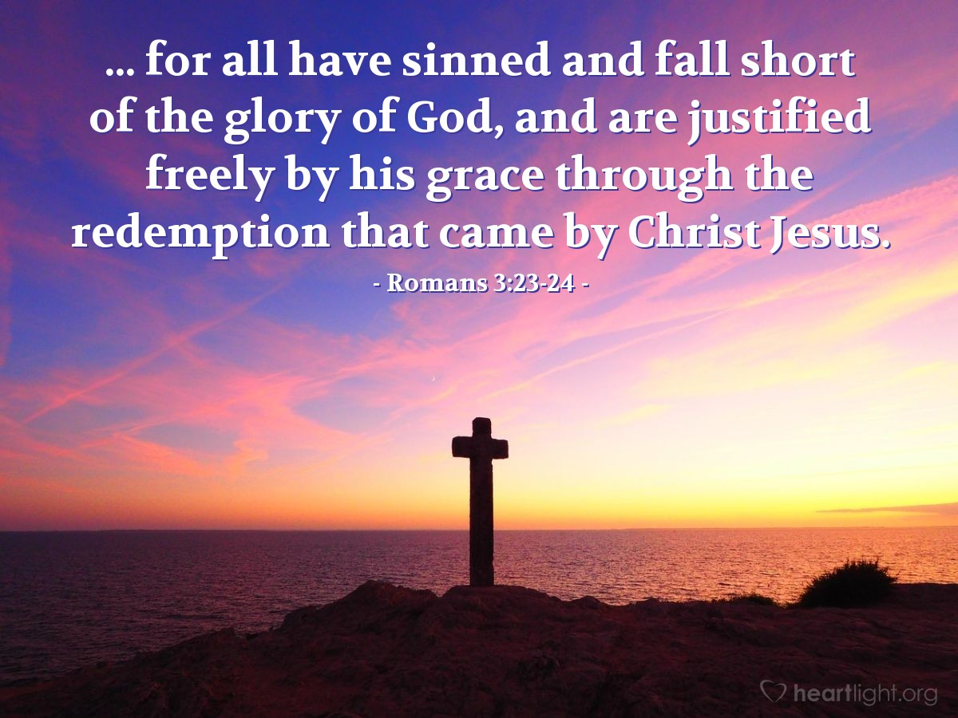
Courtesy of https://www.heartlight.org/

