Romans 1 God's works are clearly visible to man ES
Romanos 1 Las obras de Dios son claramente visibles para el hombre ES

Lesson developed by John M. Wharton March 1, 2023
http://www.biblestudyadventures.com/
Sources -
From theWord Bible program http://www.theword.net/ . Generally King James Version.
Greek, Hebrew definitions Mickelson's Enhanced Strong's, Brown-Driver-Briggs', Thayer's generally.

In Romans 1, Paul talks about mans rejection of God.  He says that mankind has known the truth about God.  They can see about God's nature in His works.  But men refused to accept Him as God.  Rather they changed the nature or form of God into idols looking like man, birds, animals, and creeping things.  They refused to think properly about God and He gave them over to reprobate minds which led to deeper sins. | En Romanos 1, Pablo habla del rechazo de Dios por parte del hombre.  Él dice que la humanidad ha conocido la verdad acerca de Dios.  Pueden ver acerca de la naturaleza de Dios en Sus obras.  Pero los hombres rehusaron aceptarlo como Dios.  Más bien, cambiaron la naturaleza o forma de Dios en ídolos con apariencia de hombre, pájaros, animales y cosas que se arrastran.  Se negaron a pensar correctamente acerca de Dios y Él los entregó a mentes reprobadas que los llevaron a pecados más profundos.

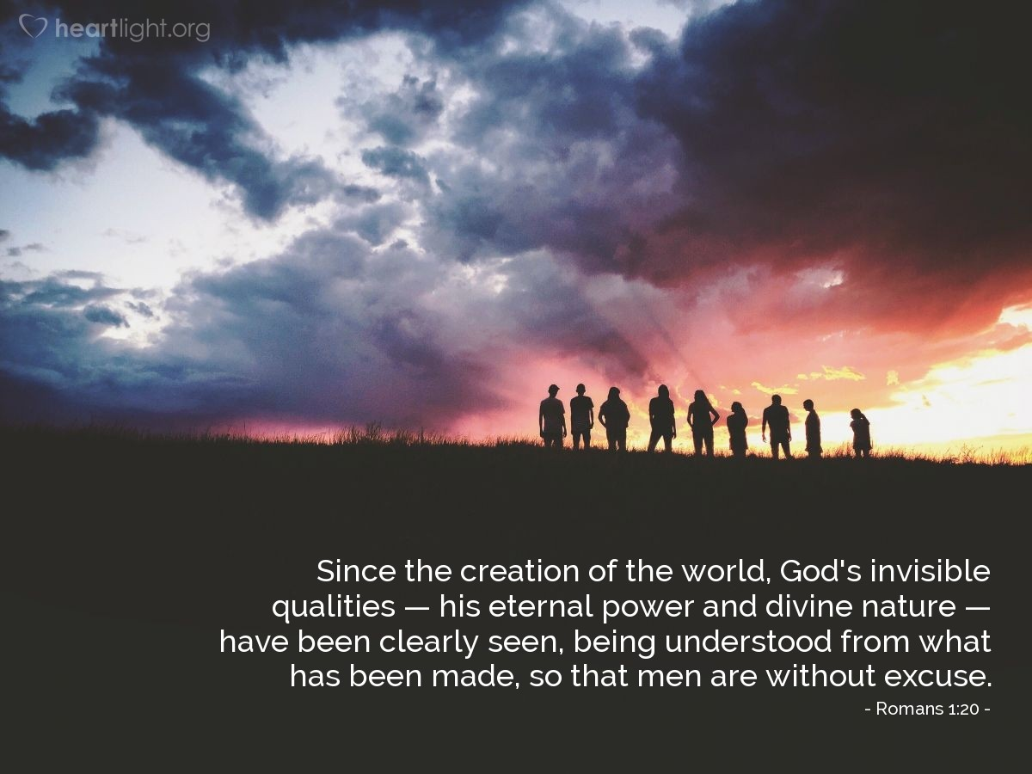
Courtesy of https://www.heartlight.org/
Paul writes to the called Believers in Rome.  Rom 1:1 AKJV/PCE Paul, a servant of Jesus Christ, called to be an apostle, separated unto the gospel of God,  Rom 1:2 AKJV/PCE (Which he had promised afore by his prophets in the holy scriptures,)  Rom 1:3 AKJV/PCE Concerning his Son Jesus Christ our Lord, which was made of the seed of David according to the flesh;  Rom 1:4 AKJV/PCE And declared to be the Son of God with power, according to the spirit of holiness, by the resurrection from the dead:  Rom 1:5 AKJV/PCE By whom we have received grace and apostleship, for obedience to the faith among all nations, for his name:  Rom 1:6 AKJV/PCE Among whom are ye also the called of Jesus Christ:  Rom 1:7 AKJV/PCE To all that be in Rome, beloved of God, called to be saints: Grace to you and peace from God our Father, and the Lord Jesus Christ.  Paul is an Apostle, servant of Christ, sent to take the Gospel to others.  This coming of Jesus Christ - the Messiah – a physical descendant of King David, the Son of God was prophesied in the Old Testament.  Isa 7:14 AKJV/PCE Therefore the Lord himself shall give you a sign; Behold, a virgin shall conceive, and bear a son, and shall call his name Immanuel.  Isa 9:6 AKJV/PCE For unto us a child is born, unto us a son is given: and the government shall be upon his shoulder: and his name shall be called Wonderful, Counseller, The mighty God, The everlasting Father, The Prince of Peace.  Jer 23:5 AKJV/PCE ¶ Behold, the days come, saith the LORD, that I will raise unto David a righteous Branch, and a King shall reign and prosper, and shall execute judgment and justice in the earth.  Paul and his co-workers have received grace from God and were made Apostles to take this Gospel to the nations.  Paul writes here to these Believers in Rome who have been called by God to this faith in Jesus Christ.  Paul prays for these Roman Christians.  Rom 1:8 AKJV/PCE First, I thank my God through Jesus Christ for you all, that your faith is spoken of throughout the whole world.  Rom 1:9 AKJV/PCE For God is my witness, whom I serve with my spirit in the gospel of his Son, that without ceasing I make mention of you always in my prayers;  Rom 1:10 AKJV/PCE Making request, if by any means now at length I might have a prosperous journey by the will of God to come unto you.  Rom 1:11 AKJV/PCE For I long to see you, that I may impart unto you some spiritual gift, to the end ye may be established;  Rom 1:12 AKJV/PCE That is, that I may be comforted together with you by the mutual faith both of you and me.  Their faith is widely known and talked about.  Paul is very thankful for these Christians in Rome. And he is always praying for them for them regularly.  Paul wants to come see them and establish them.  Established = 1. to set fast. 2. (literally) to turn resolutely in a certain direction. 3. (figuratively) to confirm.  He wants to encourage them and be encouraged by them.  God's Righteousness is revealed – the Just live by Faith!  Rom 1:13 AKJV/PCE Now I would not have you ignorant, brethren, that oftentimes I purposed to come unto you, (but was let hitherto,) that I might have some fruit among you also, even as among other Gentiles.  Rom 1:14 AKJV/PCE I am debtor both to the Greeks, and to the Barbarians; both to the wise, and to the unwise.  Rom 1:15 AKJV/PCE So, as much as in me is, I am ready to preach the gospel to you that are at Rome also.  Rom 1:16 AKJV/PCE For I am not ashamed of the gospel of Christ: for it is the power of God unto salvation to every one that believeth; to the Jew first, and also to the Greek.  Rom 1:17 AKJV/PCE For therein is the righteousness of God revealed from faith to faith: as it is written, The just shall live by faith.  Rom 1:18 AKJV/PCE For the wrath of God is revealed from heaven against all ungodliness and unrighteousness of men, who hold the truth in unrighteousness;  Rom 1:19 AKJV/PCE Because that which may be known of God is manifest in them; for God hath shewed it unto them.  Rom 1:20 AKJV/PCE For the invisible things of him from the creation of the world are clearly seen, being understood by the things that are made, even his eternal power and Godhead; so that they are without excuse:  Paul has wanted to come preach to the Christians in Rome as he has with other Gentiles.  The Gospel message of Jesus Christ leads to Salvation for all people – to the Jewish people first and to the Gentiles. The Gospel leads to Righteousness.  Righteousness = 1. equity (of character or act).  2. righteousness.  In Salvation God's righteousness is shown.  Surely God's grace in Saving mankind through Faith.  From faith to faith as the Just live by faith.  Faith to faith as we begin this walk in faith and at our end go to God through our faith.  Hab 2:4 AKJV/PCE Behold, his soul which is lifted up is not upright in him: but the just shall live by his faith.  God's wrath comes upon people's sinfulness.  Ungodliness = 1. irreverence. 2. (by implication) wickedness.  Unrighteousness = 1. (legally) injustice. 2. (properly) the quality of being unjust. 3. (by implication) the act of injustice.  4. (morally) unrighteousness, wrongfulness (of character, life or act).  These wicked men keep God's truth in unrighteousness, that is they suppress it.  Paul says that God has revealed Himself and His ways to mankind. We can see God's nature in what He has created.  Rom 1:20 ESV2011 For his invisible attributes, namely, his eternal power and divine nature, have been clearly perceived, ever since the creation of the world, in the things that have been made. So they are without excuse.  Ancient man changed God into an image.  Rom 1:21 AKJV/PCE Because that, when they knew God, they glorified him not as God, neither were thankful; but became vain in their imaginations, and their foolish heart was darkened.  Rom 1:22 AKJV/PCE Professing themselves to be wise, they became fools,  Rom 1:23 AKJV/PCE And changed the glory of the uncorruptible God into an image made like to corruptible man, and to birds, and fourfooted beasts, and creeping things.  Rom 1:24 AKJV/PCE Wherefore God also gave them up to uncleanness through the lusts of their own hearts, to dishonour their own bodies between themselves:  Rom 1:25 AKJV/PCE Who changed the truth of God into a lie, and worshipped and served the creature more than the Creator, who is blessed for ever. Amen.  Rom 1:26 AKJV/PCE For this cause God gave them up unto vile affections: for even their women did change the natural use into that which is against nature:  Rom 1:27 AKJV/PCE And likewise also the men, leaving the natural use of the woman, burned in their lust one toward another; men with men working that which is unseemly, and receiving in themselves that recompence of their error which was meet.  The Scientific world views mankind as having developed their Religious views of God over time.  But God's Word says that mankind early on knew God.  But they intentionally became vain and foolish in their thinking about God.  M-Strongs Definitions -  Vain = 1. to render (passively, become) foolish. 2. (morally) wicked. 3. (specially) idolatrous.  Imaginations = 1. discussion. 2. (internal) consideration.  3. (external) debate. 4. (by implication) purpose.  Fools = 1. unintelligent. 2. (by implication) wicked.  Heart = 1. the heart. 2. (figuratively) the thoughts or feelings (mind).  Darkened = to obscure.  UNDERSTAND - They did this on purpose. Intentionally. Rebelliously.  Dr. Pett - Note that it was not that men did not ‘know’ God. There was something within them which made them aware of Him. That is why there is so much religion in the world. But what they did not want was to be controlled by Him in their activities and behaviour. Thus they closed their minds to the knowledge of God as He is, and refused to glorify Him as God. Note that it is seen as deliberate. True knowledge of God was not seen as convenient. Nor did they render Him thanks. Note the emphasis on the fact that they were ungrateful. They took what He provided for granted, but would not acknowledge it. So instead they became vain and empty in their thinking and in their reasonings as they sought to find ways to satisfy the emptiness within, without recourse to God. But the result of rejecting the light was that their senseless heart was darkened. They found themselves struggling in the dark and sought to come up with a solution which would satisfy their desires and the desires of the masses, without having to face up to the truth.  So they tell everyone that they are wise. Really intelligent.  But their fools = 1. to become dull, bland, indistinct.  2. (figuratively) to make dull or foolish. 3. (passively) act dull-witted or as a fool.  Then they changed = to change, transform, make different  the nature of the uncorruptible = undecaying (in essence or continuance) God into images of things that are corruptible = 1. decayed. 2. (by implication) perishable like man, birds, animals and (creeping) = 1. a reptile. 2. (by Hebraism) a small animal.  So God got tired of this and gave them over to = to surrender, i.e yield up, intrust, transmit to impurity.  This comes through their own lusts = 1. a longing. 2. (especially) a lust for what is forbidden.  They dishonored their own bodies between themselves.  Dishonored =1. to render infamous. 2. (by implication) contemn or maltreat.  These people changed the truth of God to falsehood!  And they reverenced and gave religious service to created things more than to God!  Because of this God surrendered them to dishonorable passions sexual lusts.  The women changed the natural = 1. “physical.” 2. (by implication) instinctive to whats against nature = 1. growth (by germination or expansion). 2. (by implication) natural production (lineal descent). 3. (by extension) a genus or sort. 4. (figuratively) native disposition, constitution or usage.  Likewise the men left the natural = 1. “physical.” 2. (by implication) instinctive use of women – and burned = inflame deeply in excitement of the mind, i.e. longing after other men!  Doing the unseemly = 1. a lack of form. 2. (morally) an indecency. 3. (by implication) the genitalia, pudenda  these received in themselves the recompense, repayment  of their straying or wandering from the straight path.  Mankind has fallen deeply into sin!  Rom 1:28 AKJV/PCE And even as they did not like to retain God in their knowledge, God gave them over to a reprobate mind, to do those things which are not convenient;  Rom 1:29 AKJV/PCE Being filled with all unrighteousness, fornication, wickedness, covetousness, maliciousness; full of envy, murder, debate, deceit, malignity; whisperers,  Rom 1:30 AKJV/PCE Backbiters, haters of God, despiteful, proud, boasters, inventors of evil things, disobedient to parents,  Rom 1:31 AKJV/PCE Without understanding, covenantbreakers, without natural affection, implacable, unmerciful:  Rom 1:32 AKJV/PCE Who knowing the judgment of God, that they which commit such things are worthy of death, not only do the same, but have pleasure in them that do them.  NOTICE these people didn't even want to think about God.  So God surrendered them to reprobate = 1. unacceptable, i.e. rejected. 2. (by implication) worthless minds that did wrong things.  Some of the Definitions are interesting -  Fornication = 1. prostitution (including adultery, incest, and porn) 2. (by extension) unwedded stimulation or fulfillment of sexual desire.  Wickedness = depravity  Debate = strife  Malignity = bad character.  Covenant breakers = not agreed, i.e. treacherous to compacts.  Without natural affection = 1. without affection for family (parents or children) 2. (thus) hard-hearted towards kindred.  Implacable = 1. (literally) without libation (which usually accompanied a treaty) 2. (by implication) truceless.  NOTICE HERE That Paul says these people know that they face God's judgment for doing these things!  Yet they go right ahead and do them!  And they think well of others who do these things! | Pablo escribe a los creyentes llamados en Roma.  Rom 1:1 RVG10 Pablo, siervo de Jesucristo, llamado a ser apóstol, apartado para el evangelio de Dios,  Rom 1:2 RVG10 que Él había prometido antes por sus profetas en las Santas Escrituras,  Rom 1:3 RVG10 tocante a su Hijo Jesucristo, nuestro Señor, que fue hecho de la simiente de David según la carne,  Rom 1:4 RVG10 y que fue declarado ser el Hijo de Dios con poder, según el Espíritu de santidad, por la resurrección de entre los muertos,  Rom 1:5 RVG10 por quien recibimos la gracia y el apostolado, para obediencia de la fe en todas las naciones, por su nombre;  Rom 1:6 RVG10 entre los cuales estáis también vosotros, los llamados de Jesucristo.  Rom 1:7 RVG10 A todos los que estáis en Roma, amados de Dios, llamados a ser santos. Gracia y paz a vosotros, de Dios nuestro Padre y del Señor Jesucristo.  Pablo es un Apóstol, siervo de Cristo, enviado a llevar el Evangelio a los demás.  Esta venida de Jesucristo - el Mesías - un descendiente físico del Rey David fue profetizado en el Antiguo Testamento.  Isa 7:14 RVG10 Por tanto el Señor mismo os dará señal: He aquí una virgen concebirá, y dará a luz un hijo, y llamará su nombre Emmanuel.  Isa 9:6 RVG10 Porque un niño nos es nacido, hijo nos es dado; y el principado será sobre su hombro; y se llamará su nombre Admirable, Consejero, Dios Fuerte, Padre Eterno, Príncipe de Paz.  Jer 23:5 RVG10 He aquí que vienen días, dice Jehová, en los cuales levantaré a David un Renuevo justo, y un Rey reinará y prosperará, y hará juicio y justicia en la tierra.  Pablo y sus colaboradores recibieron la gracia de Dios y fueron hechos Apóstoles para llevar este Evangelio a las naciones.  Pablo escribe aquí a estos Creyentes en Roma que han sido llamados por Dios a esta fe en Jesucristo.  Pablo ora por estos cristianos romanos.  Rom 1:8 RVG10 Primeramente doy gracias a mi Dios mediante Jesucristo acerca de todos vosotros, de que en todo el mundo se habla de vuestra fe.  Rom 1:9 RVG10 Porque testigo me es Dios, a quien sirvo en mi espíritu en el evangelio de su Hijo, que sin cesar hago mención de vosotros siempre en mis oraciones,  Rom 1:10 RVG10 rogando que de alguna manera ahora al fin, por la voluntad de Dios, haya de tener próspero viaje para ir a vosotros.  Rom 1:11 RVG10 Porque deseo veros, para impartiros algún don espiritual, para que seáis afirmados,  Rom 1:12 RVG10 esto es, para que sea yo confortado juntamente con vosotros por la fe mutua, mía y vuestra.  Su fe es ampliamente conocida y comentada.  Pablo está muy agradecido por estos cristianos en Roma. Y él siempre está orando por ellos regularmente.  Pablo quiere venir a verlos y establecerlos.  Establecido (Google Translate) = 1. establecer rápido. 2. (literalmente) girar resueltamente en cierta dirección. 3. (en sentido figurado) confirmar.  Quiere animarlos y ser alentado por ellos.  La justicia de Dios se revela: ¡los justos viven por la fe!  Rom 1:13 RVG10 Mas no quiero, hermanos, que ignoréis que muchas veces me he propuesto ir a vosotros (pero hasta ahora he sido estorbado) para tener algún fruto también entre vosotros, así como entre los otros gentiles.  Rom 1:14 RVG10 A griegos y a bárbaros; a sabios y a no sabios soy deudor.  Rom 1:15 RVG10 Así que, en cuanto a mí, presto estoy a predicar el evangelio también a vosotros que estáis en Roma.  Rom 1:16 RVG10 Porque no me avergüenzo del evangelio de Cristo; porque es el poder de Dios para salvación a todo aquel que cree; al judío primeramente, y también al griego.  Rom 1:17 RVG10 Porque en él la justicia de Dios es revelada de fe en fe, como está escrito: Mas el justo por la fe vivirá.  Rom 1:18 RVG10 Porque la ira de Dios se revela desde el cielo contra toda impiedad e injusticia de los hombres, que con injusticia detienen la verdad;  Rom 1:19 RVG10 porque lo que de Dios se conoce les es manifiesto; porque Dios se lo manifestó.  Rom 1:20 RVG10 Porque las cosas invisibles de Él, su eterno poder y Divinidad, son claramente visibles desde la creación del mundo, siendo entendidas por las cosas que son hechas; así que no tienen excusa.  Pablo ha querido venir a predicar a los cristianos en Roma como lo ha hecho con otros gentiles.  El mensaje del Evangelio de Jesucristo conduce a la Salvación para todas las personas, primero para el pueblo judío y para los gentiles. El Evangelio lleva a la Justicia.  Justicia (Google Translate) = 1. equidad (de carácter o acto).  2. justicia.  En la salvación se muestra la justicia de Dios.  Seguramente la gracia de Dios en Salvar a la humanidad a través de la Fe.  De la fe a la fe como los Justos viven por la fe.  Fe a fe al comenzar este caminar en fe y al final ir a Dios a través de nuestra fe.  Hab 2:4 RVG10 He aquí se enorgullece aquel cuya alma no es recta en él; mas el justo por su fe vivirá.  La ira de Dios viene sobre la pecaminosidad de las personas.  Impiedad (Google Translate) = 1. irreverencia. 2. (por implicación) maldad.  Injusticia (Google Translate) = 1. (legalmente) injusticia. 2. (propiamente) la cualidad de ser injusto. 3. (por implicación) el acto de injusticia.  4. (moralmente) injusticia, ilicitud (de carácter, vida o acto).  Estos hombres malvados guardan la verdad de Dios en la injusticia, es decir, la reprimen.  Pablo dice que Dios se ha revelado a sí mismo y sus caminos a la humanidad. Podemos ver la naturaleza de Dios en lo que Él ha creado.  Rom 1:20 LBLA Porque desde la creación del mundo, sus atributos invisibles, su eterno poder y divinidad, se han visto con toda claridad, siendo entendidos por medio de lo creado, de manera que no tienen excusa.  El hombre antiguo transformó a Dios en una imagen.  Rom 1:21 RVG10 Porque habiendo conocido a Dios, no le glorificaron como a Dios, ni le dieron gracias; antes se envanecieron en sus discursos, y su necio corazón fue entenebrecido.  Rom 1:22 RVG10 Profesando ser sabios, se hicieron necios,  Rom 1:23 RVG10 y cambiaron la gloria del Dios incorruptible, en semejanza de imagen de hombre corruptible, y de aves, y de cuadrúpedos, y de reptiles.  Rom 1:24 RVG10 Por lo cual también Dios los entregó a la inmundicia, a las concupiscencias de sus corazones, a que deshonrasen entre sí sus propios cuerpos,  Rom 1:25 RVG10 ya que cambiaron la verdad de Dios por la mentira, adorando y sirviendo a la criatura antes que al Creador, el cual es bendito por siempre. Amén.  Rom 1:26 RVG10 Por esto Dios los entregó a pasiones vergonzosas; pues aun sus mujeres cambiaron el uso natural por el que es contra naturaleza;  Rom 1:27 RVG10 y de la misma manera también los hombres, dejando el uso natural de la mujer, se encendieron en su lascivia unos con otros, cometiendo cosas nefandas hombres con hombres, recibiendo en sí mismos la recompensa que convino a su extravío.  El mundo científico ve a la humanidad como habiendo desarrollado sus puntos de vista religiosos de Dios con el tiempo.  Pero la Palabra de Dios dice que la humanidad conoció a Dios desde el principio. Pero intencionalmente se volvieron vanos y necios en su forma de pensar acerca de Dios.  Definiciones de M-Strongs (Traductor de Google) -  Vano = 1. volverse (pasivamente, volverse) tonto. 2. (moralmente) malvado. 3. (especialmente) idólatra.  Imaginaciones = 1. discusión. 2. consideración (interna).  3. debate (externo). 4. (por implicación) propósito.  Tonto = 1. poco inteligente. 2. (por implicación) malvado.  Corazón = 1. el corazón. 2. (en sentido figurado) los pensamientos o sentimientos (mente).  Oscurecido = oscurecer.  ENTIENDE - Hicieron esto a propósito. Intencionalmente. Rebeldemente.  Dr. Pett (Traductor de Google) - Tenga en cuenta que no era que los hombres no "conocieran" a Dios. Había algo dentro de ellos que les hizo conscientes de Él. Por eso hay tanta religión en el mundo. Pero lo que no querían era ser controlados por Él en sus actividades y comportamiento. Así cerraron sus mentes al conocimiento de Dios tal como es, y rehusaron glorificarlo como Dios. Tenga en cuenta que se ve como deliberado. El verdadero conocimiento de Dios no se consideraba conveniente. Tampoco le dieron gracias. Nótese el énfasis en el hecho de que eran desagradecidos. Ellos dieron por sentado lo que Él proveyó, pero no lo reconocieron. Entonces, en cambio, se volvieron vanos y vacíos en su pensamiento y en sus razonamientos mientras buscaban formas de satisfacer el vacío interior, sin recurrir a Dios. Pero el resultado de rechazar la luz fue que su corazón insensato se oscureció. Se encontraron luchando en la oscuridad y buscaron encontrar una solución que satisficiera sus deseos y los deseos de las masas, sin tener que enfrentarse a la verdad.  Entonces les dicen a todos que son sabios. Realmente inteligente.  Pero sus tontos = 1. volverse aburridos, sosos, indistintos.  2. (en sentido figurado) hacer aburrido o tonto. 3. (pasivamente) actuar como tonto o tonto.  Luego cambiaron = cambiar, transformar, hacer diferente  la naturaleza de lo incorruptible = incorruptible (en esencia o continuación) Dios en imágenes de cosas que son corruptibles = 1. decaído. 2. (por implicación) perecedero como el hombre, pájaros, animales y (rastrero) = 1. un reptil. 2. (por hebraísmo) un animal pequeño.  Entonces Dios se cansó de esto y los entregó a = rendirse, es decir, ceder, confiar, transmitir a la impureza.  Esto viene a través de sus propias lujurias = 1. un anhelo. 2. (especialmente) una lujuria por lo que está prohibido.  Deshonraron sus propios cuerpos entre ellos.  Deshonrado =1. hacer infame. 2. (por implicación) menospreciar o maltratar.  ¡Estas personas cambiaron la verdad de Dios en falsedad!  ¡Y reverenciaban y daban servicio religioso a las cosas creadas más que a Dios!  Por eso Dios los entregó a pasiones vergonzosas y lujurias sexuales.  Las mujeres cambiaron lo natural = 1. “físico”. 2. (por implicación) instintivo a lo que está en contra de la naturaleza = 1. crecimiento (por germinación o expansión). 2. (por implicación) producción natural (descendencia lineal). 3. (por extensión) un género o especie. 4. (en sentido figurado) disposición, constitución o uso nativo.  Asimismo los hombres dejaron lo natural = 1. “físico”. 2. (por implicación) uso instintivo de las mujeres – y quemado = inflamar profundamente en la excitación de la mente, es decir, ¡anhelar a otros hombres!  Hacer lo indecoroso = 1. falta de forma. 2. (moralmente) una indecencia. 3. (por implicación) los genitales, pudenda  estos recibieron en sí mismos la recompensa, el pago  de su desvío o extravío del camino recto.  ¡La humanidad ha caído profundamente en el pecado!  Rom 1:28 RVG10 Y como no les pareció retener a Dios en su conocimiento, Dios los entregó a una mente reprobada, para hacer lo que no conviene;  Rom 1:29 RVG10 estando atestados de toda iniquidad, fornicación, malicia, avaricia, maldad; llenos de envidias, homicidios, contiendas, engaños, malignidades;  Rom 1:30 RVG10 murmuradores, detractores, aborrecedores de Dios, injuriosos, soberbios, altivos, inventores de males, desobedientes a los padres;  Rom 1:31 RVG10 necios, desleales, sin afecto natural, implacables, sin misericordia;  Rom 1:32 RVG10 quienes conociendo el juicio de Dios, que los que hacen tales cosas son dignos de muerte, no sólo las hacen, sino que aun consienten a los que las hacen.  TENGA EN CUENTA que estas personas ni siquiera querían pensar en Dios.  Entonces Dios los entregó a réprobos = 1. inaceptable, es decir, rechazado. 2. (por implicación) mentes inútiles que hicieron cosas malas.  Algunas de las definiciones son interesantes:  Fornicación = 1. prostitución (incluidos el adulterio, el incesto y la pornografía) 2. (por extensión) estimulación o cumplimiento del deseo sexual fuera del matrimonio.  Maldad = depravación  Debate = lucha  Malignidad = mal carácter.  Infractores de pactos = no acordados, es decir, traicioneros a los pactos.  Sin afecto natural = 1. sin afecto por la familia (padres o hijos) 2. (así) duro de corazón hacia los parientes.  Implacable = 1. (literalmente) sin libación (que normalmente acompañaba a un tratado) 2. (por implicación) sin tregua.  ¡NOTE AQUÍ que Pablo dice que estas personas saben que enfrentan el juicio de Dios por hacer estas cosas!  ¡Sin embargo, siguen adelante y las hacen!  ¡Y piensan bien de los demás que hacen estas cosas!

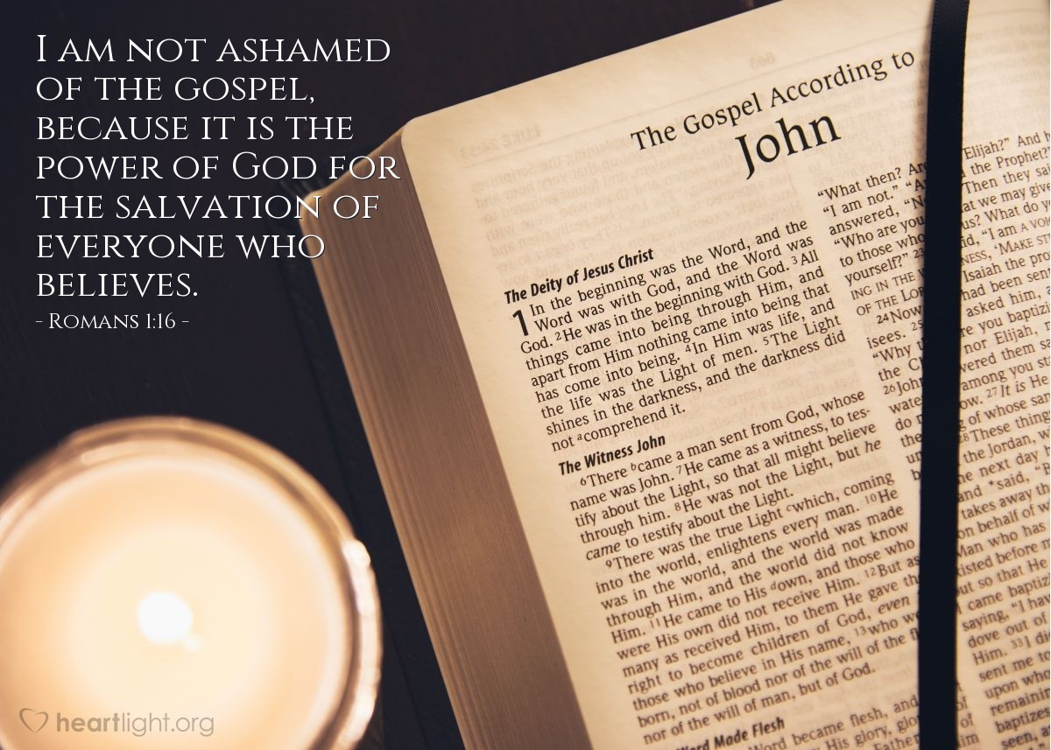
Courtesy of https://www.heartlight.org/

