Galatians 4 God has adopted us. ES
Gálatas 4 Dios nos ha adoptado. ES

Lesson developed by John M. Wharton August 16, 2022
http://www.biblestudyadventures.com/
Sources -
From theWord Bible program http://www.theword.net/ . Generally King James Version.
Greek, Hebrew definitions Mickelson's Enhanced Strong's, Brown-Driver-Briggs', Thayer's generally.

In Chapter 4 We see that God placed the people of Israel under the law for a specific time.  A that specific time Jesus came to redeem those who were under the Law.  The Law of Moses taught them right from wrong and put necessary controls over them.  By going under the Law these Galatians are returning to a system of works to earn righteousness. | En el Capítulo 4 vemos que Dios colocó al pueblo de Israel bajo la ley por un tiempo específico.  En ese momento específico Jesús vino a redimir a los que estaban bajo la Ley.  La Ley de Moisés les enseñó el bien del mal y puso los controles necesarios sobre ellos.  Al someterse a la Ley, estos gálatas están regresando a un sistema de obras para ganar la justicia.

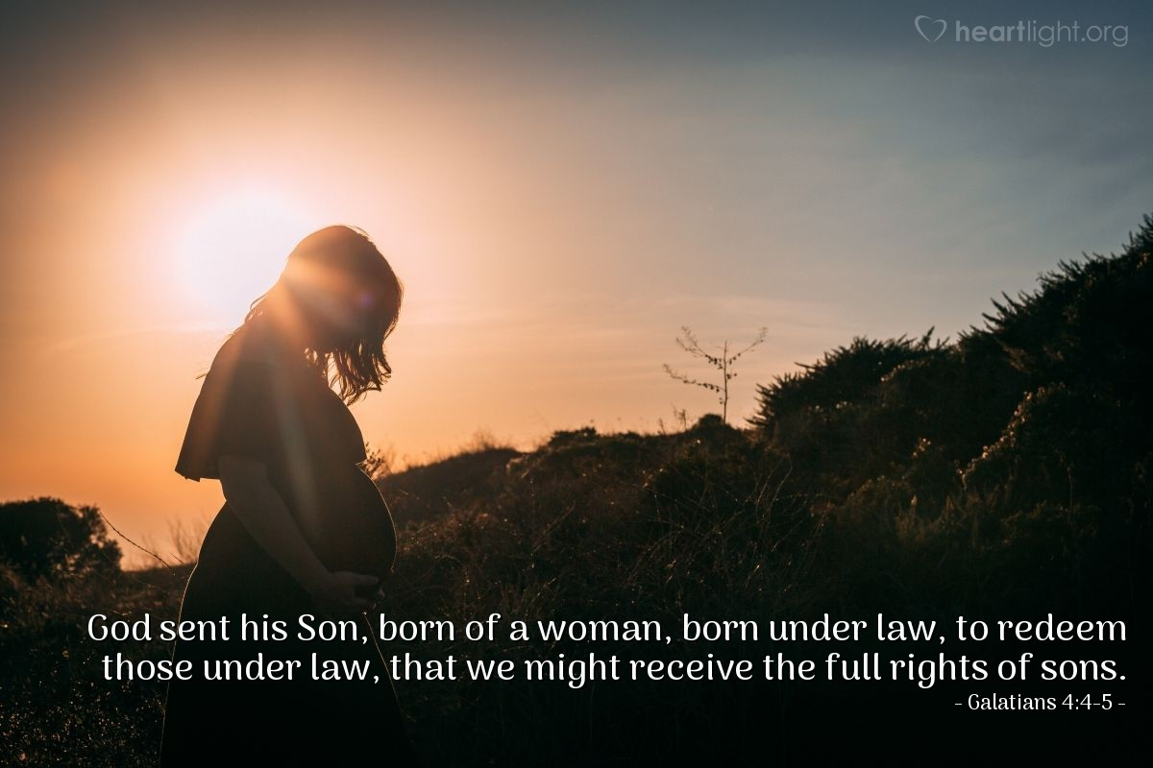
Courtesy of https://www.heartlight.org/

God put Israel under the Law for a specific time.  Gal 4:1 AKJV/PCE Now I say, That the heir, as long as he is a child, differeth nothing from a servant, though he be lord of all;  Gal 4:2 AKJV/PCE But is under tutors and governors until the time appointed of the father.  Gal 4:3 AKJV/PCE Even so we, when we were children, were in bondage under the elements of the world:  Paul is talking here about Israel which is God's covenant people.  But God put them under the control of the Law for a specific period of time – while they were children.  Verse 4 below completes the point that Israel was under the Law for a specific time.  The Law was needed to teach right from wrong and to control the people of Israel until the time God the Father had appointed for Jesus sacrifice for sins.  THOUGHT – This indicates that God did not mean for the Law to be over Israel for ever.  An element can mean an orderly arrangement or a fundamental principle.  So the Law was a system of fundamental principles pertinent to this world and sinful human nature teaching right from wrong and controlling the people.  The time in God's Plan came!  Gal 4:4 AKJV/PCE But when the fulness of the time was come, God sent forth his Son, made of a woman, made under the law,  Gal 4:5 AKJV/PCE To redeem them that were under the law, that we might receive the adoption of sons.  Gal 4:6 AKJV/PCE And because ye are sons, God hath sent forth the Spirit of his Son into your hearts, crying, Abba, Father.  Gal 4:7 AKJV/PCE Wherefore thou art no more a servant, but a son; and if a son, then an heir of God through Christ.  The time in God's plan was completed.  It was time for God's Son to redeem – to get back – Israel from under the control of sin.  Actually it was Judah at that point.  Daniel prophesied about this coming time -  Dan 9:26 AKJV/PCE And after threescore and two weeks shall Messiah be cut off, but not for himself: and the people of the prince that shall come shall destroy the city and the sanctuary; and the end thereof shall be with a flood, and unto the end of the war desolations are determined.  Verse 25 shows that there was a period of seven sevens and this one of sixty two sevens. That made a total of sixty nine sevens of years. That leaves that last seven years in the time of Great Tribulation seen in Daniel 9:27.  God wanted to adopt them as sons.  THOUGHT – They were already God's chosen people.  This son ship was thus a closer more personal relation to the Father.  Now God also wants to adopt those among the Gentiles who accept salvation through Jesus.  Acts 28:28 AKJV/PCE Be it known therefore unto you, that the salvation of God is sent unto the Gentiles, and that they will hear it.  As Christians we have God's Spirit inside leading us.  We're not servants under the Law now – But sons and thus heirs through Jesus sacrifice.  You used to worship false gods!  Gal 4:8 AKJV/PCE Howbeit then, when ye knew not God, ye did service unto them which by nature are no gods.  Gal 4:9 AKJV/PCE But now, after that ye have known God, or rather are known of God, how turn ye again to the weak and beggarly elements, whereunto ye desire again to be in bondage?  Gal 4:10 AKJV/PCE Ye observe days, and months, and times, and years.  Gal 4:11 AKJV/PCE I am afraid of you, lest I have bestowed upon you labour in vain.  Gal 4:12 AKJV/PCE Brethren, I beseech you, be as I am; for I am as ye are: ye have not injured me at all.  Paul tells these Galatians that before they knew the true God they worshiped things that weren't really a god at all.  In other words, they worshiped idols.  POINT - So Paul is talking to Gentiles here – not Jewish Christians. Because the Jewish people generally were not worshiping idols at this point.  Then Paul tells them that now they have known God and are known by Him!  NOTICE – Paul says that now they are turning again to weak poor elemental things as they are going under the Law.  UNDERSTAND – Paul indicates here that a Gentile Christian who has known God and been saved and then turns to circumcision and the works of Law is doing much the same as they did before when they were idol worshiper.  That person is turning again to basic simplistic approaches like sacrifices and honoring special religious days to be righteous before God.  Approaches that God won't accept!  Paul is worried that he will have worked so hard preaching the Gospel to them and now they will turn from it.  UNDERSTAND THIS - This doesn't mean that since we are not subject to the Law of Moses that we can do whatever we want.  There is right and wrong. The Ten Commandments showed that. And we see those points expressed often with more detail and understanding in Paul's Epistles to the Gentile Churches. So we are subject to a higher standard because the Spirit of God is within us if we are Christians. But we don't get circumcised or try to keep the Law.  The Galatians accepted Paul even when he was sick.  Gal 4:13 AKJV/PCE Ye know how through infirmity of the flesh I preached the gospel unto you at the first.  Gal 4:14 AKJV/PCE And my temptation which was in my flesh ye despised not, nor rejected; but received me as an angel of God, even as Christ Jesus.  Gal 4:15 AKJV/PCE Where is then the blessedness ye spake of? for I bear you record, that, if it had been possible, ye would have plucked out your own eyes, and have given them to me.  Gal 4:16 AKJV/PCE Am I therefore become your enemy, because I tell you the truth?  Paul was sick before when he had preached the Gospel to the Galatians.  At that time the Galatians hadn't despised or ignored Paul but had accepted him as from God.  They did all that they could to help Paul when he was sick.  QUESTION – So Paul asks them if he is their enemy now because he is telling them the truth about their error in being circumcised?!  Paul is concerned about these Galatians!  Gal 4:17 AKJV/PCE They zealously affect you, but not well; yea, they would exclude you, that ye might affect them.  Gal 4:18 AKJV/PCE But it is good to be zealously affected always in a good thing, and not only when I am present with you.  Gal 4:19 AKJV/PCE My little children, of whom I travail in birth again until Christ be formed in you,  Gal 4:20 AKJV/PCE I desire to be present with you now, and to change my voice; for I stand in doubt of you.  These false teachers are zealous in their approach to the Galatians. But they are misleading them.  Gal 4:17 NIV Those people are zealous to win you over, but for no good. What they want is to alienate you from us, so that you may have zeal for them.  Paul wants to go be with them. He is very concerned that these Galatians will be mislead away from the truth of the Gospel.  Listen to what the Law says!  Gal 4:21 AKJV/PCE Tell me, ye that desire to be under the law, do ye not hear the law?  Gal 4:22 AKJV/PCE For it is written, that Abraham had two sons, the one by a bondmaid, the other by a freewoman.  Gal 4:23 AKJV/PCE But he who was of the bondwoman was born after the flesh; but he of the freewoman was by promise.  Paul uses an allegory here to show the difference between the Law of Moses and Grace.  Abraham had two sons –  Ishmael who was born from Hagar, a bondwoman, a slave or servant.  Isaac was born from a free woman – Sarah. He was a son of promise.  This shows us that the law is being likened to bondage. And Paul has already shown that those under the Law are under a curse to do all of it.  But Abraham believed God's promise about Isaac and God declared him righteous for his faith.  The two covenants through Abraham.  Gal 4:24 AKJV/PCE Which things are an allegory: for these are the two covenants; the one from the mount Sinai, which gendereth to bondage, which is Agar.  Gal 4:25 AKJV/PCE For this Agar is mount Sinai in Arabia, and answereth to Jerusalem which now is, and is in bondage with her children.  Gal 4:26 AKJV/PCE But Jerusalem which is above is free, which is the mother of us all.  Gal 4:27 AKJV/PCE For it is written, Rejoice, thou barren that bearest not; break forth and cry, thou that travailest not: for the desolate hath many more children than she which hath an husband.  Gal 4:28 AKJV/PCE Now we, brethren, as Isaac was, are the children of promise.  Gal 4:29 AKJV/PCE But as then he that was born after the flesh persecuted him that was born after the Spirit, even so it is now.  Gal 4:30 AKJV/PCE Nevertheless what saith the scripture? Cast out the bondwoman and her son: for the son of the bondwoman shall not be heir with the son of the freewoman.  Gal 4:31 AKJV/PCE So then, brethren, we are not children of the bondwoman, but of the free.  Now in this allegory there are two covenants.  The one connects to Mount Sinai where Moses received the Law (at least the Ten Commandments).  That connects to Jerusalem where the people are still in bondage to the Law.  Then Paul points to a prophecy (Isaiah 54) looking forward to the house of Israel's acceptance and marriage to the Lord once again.  Isa 54:1 AKJV/PCE Sing, O barren, thou that didst not bear; break forth into singing, and cry aloud, thou that didst not travail with child: for more are the children of the desolate than the children of the married wife, saith the LORD.  This prophecy also refers to Israel inheriting the Gentiles.  The prophecy also notes that this barren one will have more children – Spiritual Children also – than the married wife which is the house of Judah.  Thus proving that this prophecy refers to the house of Israel which was divorced from God in the Old Testament.  Jer 3:8 AKJV/PCE And I saw, when for all the causes whereby backsliding Israel committed adultery I had put her away, and given her a bill of divorce; yet her treacherous sister Judah feared not, but went and played the harlot also.  This second covenant connects with the New Jerusalem which is above at this time.  Paul describes this new city that God has prepared for the saints as like a mother to us.  So this also connects to we Christians who are of promise just like Isaac was.  INTERESTINGLY – Paul points out that Ishmael – the one born after the flesh – persecuted Isaac – the one born after the Spirit just as the Jewish people did to the Christians at that time also.  TAKE NOTE - Paul points out also that God told Abraham to throw the bondwoman and her son out!  Her son was not to be an heir of Abraham.  Sarah told Abraham to do this. And God confirmed it to Abraham.  Gen 21:10 AKJV/PCE Wherefore she said unto Abraham, Cast out this bondwoman and her son: for the son of this bondwoman shall not be heir with my son, even with Isaac.  Gen 21:11 AKJV/PCE And the thing was very grievous in Abraham's sight because of his son.  Gen 21:12 AKJV/PCE ¶ And God said unto Abraham, Let it not be grievous in thy sight because of the lad, and because of thy bondwoman; in all that Sarah hath said unto thee, hearken unto her voice; for in Isaac shall thy seed be called.  IMPORTANT - This allegory shows us clearly that we are not children of the bondwoman but rather children of the free woman.  POINT Being that free – we are Not Under the Law! | Dios puso a Israel bajo la Ley por un tiempo específico.  Gal 4:1 RVG10 Además digo: Entre tanto que el heredero es niño, en nada difiere del siervo, aunque es señor de todo;  Gal 4:2 RVG10 mas está bajo tutores y mayordomos hasta el tiempo señalado por el padre.  Gal 4:3 RVG10 Así también nosotros, cuando éramos niños, estábamos en esclavitud bajo los rudimentos del mundo.  Pablo está hablando aquí de Israel, que es el pueblo del pacto de Dios.  Pero Dios los puso bajo el control de la Ley por un período de tiempo específico – mientras eran niños.  El versículo 4 a continuación completa el punto de que Israel estuvo bajo la Ley por un tiempo específico.  La Ley era necesaria para enseñar el bien del mal y para controlar al pueblo de Israel hasta el momento en que Dios el Padre había señalado para Jesús el sacrificio por los pecados.  PENSAMIENTO – Esto indica que Dios no quiso que la Ley estuviera sobre Israel para siempre.  Un elemento puede significar un arreglo ordenado o un principio fundamental.  Así que la Ley era un sistema de principios fundamentales pertinentes a este mundo y la naturaleza humana pecaminosa enseñando el bien del mal y controlando a la gente.  ¡Llegó el momento en el Plan de Dios!  Gal 4:4 RVG10 Mas venido el cumplimiento del tiempo, Dios envió a su Hijo, hecho de mujer, hecho bajo la ley,  Gal 4:5 RVG10 para que redimiese a los que estaban bajo la ley, a fin de que recibiésemos la adopción de hijos.  Gal 4:6 RVG10 Y por cuanto sois hijos, Dios envió el Espíritu de su Hijo a vuestros corazones, el cual clama: Abba, Padre.  Gal 4:7 RVG10 Así que ya no eres siervo, sino hijo; y si hijo, también heredero de Dios por Cristo.  El tiempo en el plan de Dios se completó.  Era hora de que el Hijo de Dios redimiera, recuperara a Israel del control del pecado.  En realidad era Judá en ese momento.  Daniel profetizó sobre este tiempo venidero:  Dan 9:26 RVG10 Y después de las sesenta y dos semanas se quitará la vida al Mesías, mas no por sí; y el pueblo del príncipe que ha de venir, destruirá la ciudad y el santuario; con inundación será el fin de ella, y hasta el fin de la guerra las asolaciones están determinadas.  El versículo 25 muestra que hubo un período de siete sietes y este de sesenta y dos sietes. Eso hizo un total de sesenta y nueve sietes de años. Eso deja los últimos siete años en el tiempo de la Gran Tribulación visto en Daniel 9:27.  Dios quiso adoptarlos como hijos.  PENSAMIENTO – Ya eran el pueblo elegido de Dios.  Esta filiación era así una relación más íntima y personal con el Padre.  Ahora Dios también quiere adoptar a aquellos entre los gentiles que aceptan la salvación a través de Jesús.  Acts 28:28 RVG10 Os sea, pues, notorio, que a los gentiles es enviada esta salvación de Dios; y ellos oirán.  Como cristianos, tenemos el Espíritu de Dios dentro guiándonos.  No somos siervos bajo la Ley ahora – sino hijos y por lo tanto herederos a través del sacrificio de Jesús.  ¡Solías adorar dioses falsos!  Gal 4:8 RVG10 Mas entonces, no conociendo a Dios, servíais a los que por naturaleza no son dioses.  Gal 4:9 RVG10 Mas ahora, conociendo a Dios, o más bien, siendo conocidos por Dios, ¿cómo es que os volvéis de nuevo a los débiles y pobres rudimentos, a los cuales os queréis volver a esclavizar?  Gal 4:10 RVG10 Guardáis los días, los meses, los tiempos, y los años.  Gal 4:11 RVG10 Me temo de vosotros, que haya trabajado en vano con vosotros.  Gal 4:12 RVG10 Os ruego, hermanos, que seáis como yo; porque yo soy como vosotros: Ningún agravio me habéis hecho.  Pablo les dice a estos gálatas que antes de conocer al verdadero Dios adoraban cosas que en realidad no eran un dios en absoluto.  En otras palabras, adoraban ídolos.  PUNTO - Así que Pablo está hablando a los gentiles aquí, no a los cristianos judíos. Porque el pueblo judío en general no estaba adorando ídolos en este momento.  ¡Entonces Pablo les dice que ahora han conocido a Dios y son conocidos por Él!  AVISO: Pablo dice que ahora se están volviendo de nuevo a las cosas elementales pobres y débiles, ya que se someten a la Ley.  ENTIENDE – Pablo indica que un cristiano que ha conocido a Dios y ha sido salvo y luego se vuelve a la circuncisión y las obras de la Ley está haciendo lo mismo que cuando eran idólatras.  Esa persona está recurriendo nuevamente a enfoques simplistas básicos como los sacrificios y honrando días religiosos especiales para ser justos ante Dios.  ¡Aproximaciones que Dios no aceptará!  Pablo está preocupado de que habrá trabajado tan duro predicándoles el Evangelio y ahora se apartarán de él.  ENTIENDE ESTO - Esto no significa que ya que no estamos sujetos a la Ley de Moisés, podemos hacer lo que queramos.  Hay bien y mal. Los Diez Mandamientos lo demostraron. Y vemos esos puntos expresados ​​a menudo con más detalle y comprensión en las epístolas de Pablo a las iglesias gentiles. Entonces estamos sujetos a un estándar más alto porque el Espíritu de Dios está dentro de nosotros si somos cristianos. Pero no nos circuncidamos ni tratamos de guardar la Ley.  Los gálatas aceptaron a Pablo incluso cuando estaba enfermo.  Gal 4:13 RVG10 Vosotros sabéis que en flaqueza de la carne os prediqué el evangelio al principio,  Gal 4:14 RVG10 y no desechasteis ni menospreciasteis mi prueba que estaba en mi carne, antes me recibisteis como a un ángel de Dios, como a Cristo Jesús.  Gal 4:15 RVG10 ¿Dónde está entonces vuestra bienaventuranza? Porque yo os doy testimonio de que si hubiese sido posible, os hubierais sacado vuestros propios ojos para dármelos.  Gal 4:16 RVG10 ¿Me he hecho, pues, vuestro enemigo, porque os digo la verdad?  Pablo estuvo enfermo antes cuando había predicado el Evangelio a los gálatas.  En ese momento, los gálatas no habían despreciado ni ignorado a Pablo, sino que lo habían aceptado como procedente de Dios.  Hicieron todo lo que pudieron para ayudar a Paul cuando estaba enfermo.  PREGUNTA: ¿Entonces Pablo les pregunta si él es su enemigo ahora porque les está diciendo la verdad acerca de su error al circuncidarse?  ¡Pablo está preocupado por estos gálatas!  Gal 4:17 RVG10 Ellos tienen celo de vosotros, mas no para bien; antes, os quieren apartar para que vosotros tengáis celo por ellos.  Gal 4:18 RVG10 Bueno es ser celoso en lo bueno siempre, y no solamente cuando estoy presente con vosotros.  Gal 4:19 RVG10 Hijitos míos, por quienes vuelvo a sufrir dolores de parto, hasta que Cristo sea formado en vosotros,  Gal 4:20 RVG10 querría estar ahora presente con vosotros y mudar mi voz; porque estoy perplejo de vosotros.  Estos falsos maestros son celosos en su acercamiento a los Gálatas. Pero los están engañando.  Gal 4:17 NVI Esos que muestran mucho interés por ganárselos a ustedes no abrigan buenas intenciones. Lo que quieren es alejarlos de nosotros para que ustedes se entreguen a ellos.  Paul quiere ir a estar con ellos. Está muy preocupado de que estos gálatas sean desviados de la verdad del Evangelio.  ¡Escucha lo que dice la Ley!  Gal 4:21 RVG10 Decidme, los que queréis estar bajo la ley; ¿no habéis oído la ley?  Gal 4:22 RVG10 Porque está escrito que Abraham tuvo dos hijos; uno de la sierva, y otro de la libre.  Gal 4:23 RVG10 Pero el de la sierva nació según la carne; mas el de la libre lo fue por la promesa.  Pablo usa aquí una alegoría para mostrar la diferencia entre la Ley de Moisés y la Gracia.  Abraham tuvo dos hijos:  Ismael que nació de Agar, una esclava, esclava o sierva.  Isaac nació de una mujer libre, Sara. Él era un hijo de la promesa.  Esto nos muestra que la ley está siendo comparada con la esclavitud. Y Pablo ya ha mostrado que los que están bajo la Ley están bajo maldición para hacer todo eso.  Pero Abraham creyó en la promesa de Dios acerca de Isaac y Dios lo declaró justo por su fe.  The two covenants through Abraham.  Gal 4:24 RVG10 Lo cual es una alegoría; porque éstos son los dos pactos; el uno del monte Sinaí, el cual engendra para servidumbre; el cual es Agar.  Gal 4:25 RVG10 Porque Agar es el monte Sinaí en Arabia, que corresponde a la que ahora es Jerusalén, y está en servidumbre con sus hijos.  Gal 4:26 RVG10 Mas la Jerusalén de arriba es libre; la cual es la madre de todos nosotros.  Gal 4:27 RVG10 Porque está escrito: Alégrate estéril, tú que no das a luz: Prorrumpe en júbilo y clama, tú que no tienes dolores de parto, porque más son los hijos de la dejada, que de la que tiene marido.  Gal 4:28 RVG10 Así que, hermanos, nosotros, como Isaac, somos hijos de la promesa.  Gal 4:29 RVG10 Pero como entonces el que nació según la carne, perseguía al que nació según el Espíritu; así también es ahora.  Gal 4:30 RVG10 Mas ¿qué dice la Escritura? Echa fuera a la sierva y a su hijo; porque el hijo de la sierva no será heredero con el hijo de la libre.  Gal 4:31 RVG10 Así que, hermanos, no somos hijos de la sierva, sino de la libre.  Ahora bien, en esta alegoría hay dos pactos.  El que conecta con el Monte Sinaí donde Moisés recibió la Ley (al menos los Diez Mandamientos).  Eso conecta a Jerusalén donde la gente todavía está en esclavitud a la Ley.  Luego, Pablo señala una profecía (Isaías 54) que anticipa la aceptación de la casa de Israel y su matrimonio con el Señor una vez más.  Isa 54:1 RVG10 Alégrate, oh estéril, la que no daba a luz; levanta canción, y da voces de júbilo, la que nunca estuvo de parto; porque más son los hijos de la dejada que los de la casada, dice Jehová.  Esta profecía también se refiere a que Israel heredará a los gentiles.  La profecía también nota que esta estéril tendrá más hijos – también Hijos Espirituales – que la mujer casada que es la casa de Judá.  Probando así que esta profecía se refiere a la casa de Israel que estaba divorciada de Dios en el Antiguo Testamento.  Jer 3:8 RVG10 Y yo vi cuando por causa de todo esto, cometió adulterio la infiel Israel, yo la había despedido dándole carta de repudio; y aún así no tuvo temor la rebelde Judá su hermana, sino que también ella fue y se prostituyó.  Este segundo pacto se conecta con la Nueva Jerusalén que está arriba en este momento.  Pablo describe esta nueva ciudad que Dios ha preparado para los santos como una madre para nosotros.  Así que esto también se conecta con nosotros los cristianos que somos de la promesa al igual que lo fue Isaac.  DE FORMA INTERESANTE: Pablo señala que Ismael, el nacido según la carne, persiguió a Isaac, el nacido según el Espíritu, tal como el pueblo judío también hizo con los cristianos en ese momento.  TENGA EN CUENTA: ¡Pablo también señala que Dios le dijo a Abraham que echara a la esclava y a su hijo!  Su hijo no sería heredero de Abraham.  Sara le dijo a Abraham que hiciera esto. Y Dios se lo confirmó a Abraham.  Gen 21:10 RVG10 Por tanto dijo a Abraham: Echa a esta sierva y a su hijo; pues el hijo de esta sierva no ha de heredar con mi hijo, con Isaac.  Gen 21:11 RVG10 Este dicho pareció grave en gran manera a Abraham a causa de su hijo.  Gen 21:12 RVG10 Entonces dijo Dios a Abraham: No te parezca grave a causa del muchacho y de tu sierva; en todo lo que te dijere Sara, oye su voz, porque en Isaac te será llamada descendencia.  IMPORTANTE - Esta alegoría nos muestra claramente que no somos hijos de la esclava sino hijos de la mujer libre.  PUNTO Siendo así de libres, ¡no estamos bajo la ley!

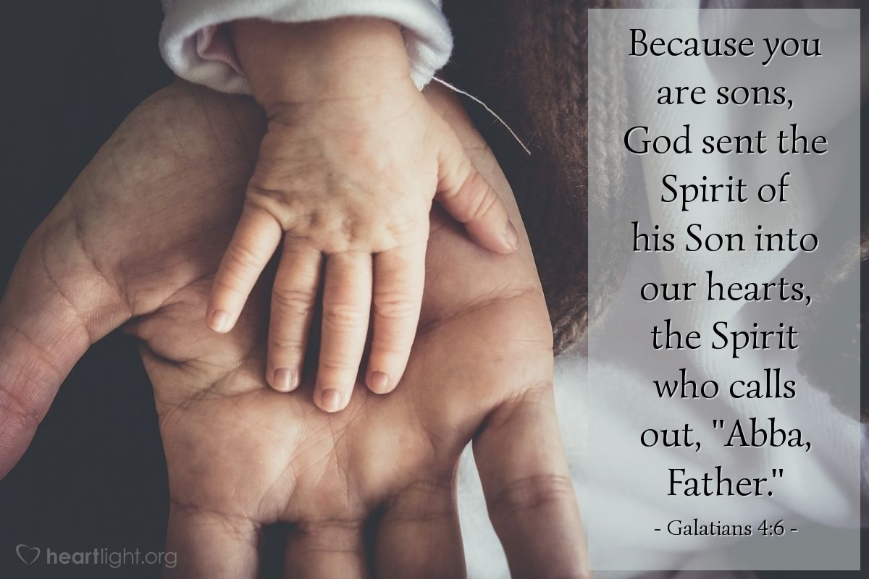
Courtesy of https://www.heartlight.org/

