Ephesians 2 Reanimated with Christ and saved by grace. ES
Efesios 2 Reanimados con Cristo y salvos por gracia. ES

Lesson developed by John M. Wharton October 10, 2022
http://www.biblestudyadventures.com/
Sources -
From theWord Bible program http://www.theword.net/ . Generally King James Version.
Greek, Hebrew definitions Mickelson's Enhanced Strong's, Brown-Driver-Briggs', Thayer's generally.

In Ephesians 2 Paul show us that we used to live just like Satan wants us to live – in Sin!  But God has enlivened us through Christ.  We are saved by the Father's grace through our faith in Jesus sacrifice for sin.  Before we were separated from God and we had No Hope!  But now as Christians we have access to the Father through the Spirit. | En Efesios 2 Pablo nos muestra que solíamos vivir como Satanás quiere que vivamos: ¡en pecado!  Pero Dios nos ha dado vida por medio de Cristo.  Somos salvos por la gracia del Padre a través de nuestra fe en el sacrificio de Jesús por el pecado.  ¡Antes estábamos separados de Dios y no teníamos esperanza!  Pero ahora como cristianos tenemos acceso al Padre a través del Espíritu.

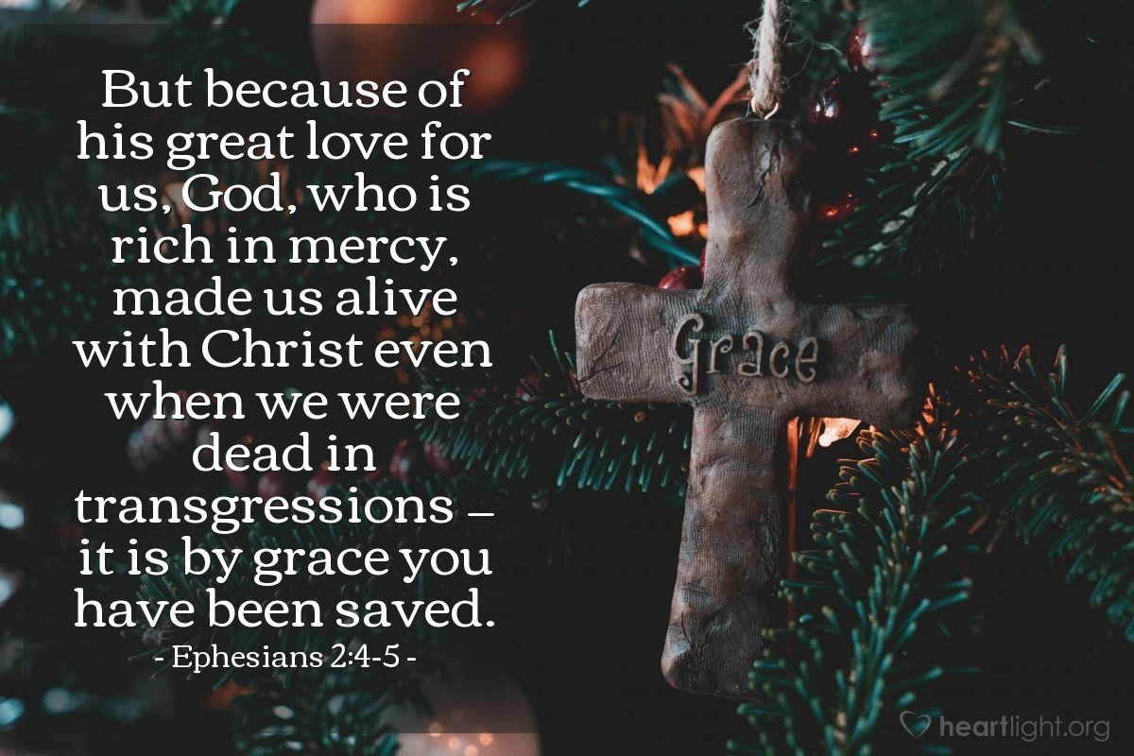
Courtesy of https://www.heartlight.org/

We used to walk according to our lusts.  Eph 2:1 AKJV/PCE And you hath he quickened, who were dead in trespasses and sins;  Eph 2:2 AKJV/PCE Wherein in time past ye walked according to the course of this world, according to the prince of the power of the air, the spirit that now worketh in the children of disobedience:  Eph 2:3 AKJV/PCE Among whom also we all had our conversation in times past in the lusts of our flesh, fulfilling the desires of the flesh and of the mind; and were by nature the children of wrath, even as others.  Here “hath he quickened” is brought up from verse 5 to show the thought.  Before we became Christians we lived like the people of this world lived – in sin, controlled by sin.  The prince of the power of the power of the air – CBN says prince = ruler, i.e. Satan – works in people to blind them to the truth and keep them bound in sin.  2Cor 4:3 AKJV/PCE But if our gospel be hid, it is hid to them that are lost:  2Cor 4:4 AKJV/PCE In whom the god of this world hath blinded the minds of them which believe not, lest the light of the glorious gospel of Christ, who is the image of God, should shine unto them.  In our previous lives – our way of living before becoming Christians – we lived in the lusts that our flesh and mind wanted.  We were headed for wrath – God's judgment for our sins.  God has reanimated us and saved us by grace!  Eph 2:4 AKJV/PCE But God, who is rich in mercy, for his great love wherewith he loved us,  Eph 2:5 AKJV/PCE Even when we were dead in sins, hath quickened us together with Christ, (by grace ye are saved;)  Eph 2:6 AKJV/PCE And hath raised us up together, and made us sit together in heavenly places in Christ Jesus:  Paul says that God is wealthy in mercy. He abounds in it.  God also had a great love for us even before we became Christians.  Before we were Christians we were dead in our sins and facing God's wrath and judgment.  But God has quickened us, reanimated us with Christ.  UNDERSTAND THIS – We are saved by God's graciousness toward us through Jesus sacrifice. We're not saved through doing works.  Rom 5:8 AKJV/PCE But God commendeth his love toward us, in that, while we were yet sinners, Christ died for us.  Rom 8:11 AKJV/PCE But if the Spirit of him that raised up Jesus from the dead dwell in you, he that raised up Christ from the dead shall also quicken your mortal bodies by his Spirit that dwelleth in you.  Paul also says in verse 5 that God (the Father) has raised us up with Christ (together) so that we can sit in heavenly places with Christ.  John saw some indication of that in Revelation 4:4 with 24 elders sitting on seats - thrones, in white clothing with gold crowns.  Rev 4:4 AKJV/PCE And round about the throne were four and twenty seats: and upon the seats I saw four and twenty elders sitting, clothed in white raiment; and they had on their heads crowns of gold.  These 24 elders surely must represent the Church of Jesus Christ (maybe the 12 apostles are hinted at) and the 12 tribes of Israel. But these elders are also representative of all we saints – both Old and New Testament. We are all around God the Father's throne.  We're saved by grace through faith – Not by works!  Eph 2:7 AKJV/PCE That in the ages to come he might shew the exceeding riches of his grace in his kindness toward us through Christ Jesus.  Eph 2:8 AKJV/PCE For by grace are ye saved through faith; and that not of yourselves: it is the gift of God:  Eph 2:9 AKJV/PCE Not of works, lest any man should boast.  Eph 2:10 AKJV/PCE For we are his workmanship, created in Christ Jesus unto good works, which God hath before ordained that we should walk in them.  Paul says that in the coming ages God will show or display (HCSB, ISV) His wonderful riches of grace – far beyond anything that could be expected – and which He has given to us through Jesus Christ.  Here again Paul makes the point clearly that we are saved by God's graciousness (M-Strongs) through our faith – our trust and reliance – in Jesus sacrifice. We are not saved through anything of ourselves or that we can do.  Rom 3:23 AKJV/PCE For all have sinned, and come short of the glory of God;  Rom 3:24 AKJV/PCE Being justified freely by his grace through the redemption that is in Christ Jesus:  This grace is a gift from God the Father. We do not receive it as a result of any work or act (M-Strongs) that we can do.  This prevents anyone from boasting that they have earned righteousness before God through their efforts.  Eph 2:9 ISV and not the result of actions, to put a stop to all boasting.  UNDERSTAND THIS – We are a product (M-Strongs) a work of God (Thayer) that He has made in Christ Jesus.  Here is a wonderful thought from Wilbur Pickering's New Testament on us being God's workmanship -  “The English word ‘poem’ comes from the Greek word here, poiema, and is one of its meanings. Just as each poem is an individual creation of the poet, so we are individual creations, not produced by a production line in a factory”.  He has made us to do good works.  We aren't saved by doing good works.  But God works on our nature and we learn to do those good works because we are Christians.  God has literally ordained or prepared in advance (M-Strongs)  that we should walk all around (M-Strongs) doing these good things that God has planned for us to do.  Estranged and without hope!  Eph 2:11 AKJV/PCE Wherefore remember, that ye being in time past Gentiles in the flesh, who are called Uncircumcision by that which is called the Circumcision in the flesh made by hands;  Eph 2:12 AKJV/PCE That at that time ye were without Christ, being aliens from the commonwealth of Israel, and strangers from the covenants of promise, having no hope, and without God in the world:  Before they became Christians these Ephesians were Gentiles – meaning that they were not Jewish.  And the Jewish people who were circumcised physically called the Gentiles uncircumcised (since they weren't circumcised).  These Gentiles were not Christians – they did not have Jesus as their Lord and Savior.  They were not part of the commonwealth of the nation of Israel.  They were foreigners not having any rights to the covenants of promise that God had made with the people of Israel.  So they as unsaved Gentiles and with no connection to God - had no hope.  UNDERSTAND THAT – this is the condition of every person who is not a Born Again Christian.  We have access to the Father by the Spirit.  Eph 2:13 AKJV/PCE But now in Christ Jesus ye who sometimes were far off are made nigh by the blood of Christ.  Eph 2:14 AKJV/PCE For he is our peace, who hath made both one, and hath broken down the middle wall of partition between us;  Eph 2:15 AKJV/PCE Having abolished in his flesh the enmity, even the law of commandments contained in ordinances; for to make in himself of twain one new man, so making peace;  Eph 2:16 AKJV/PCE And that he might reconcile both unto God in one body by the cross, having slain the enmity thereby:  Eph 2:17 AKJV/PCE And came and preached peace to you which were afar off, and to them that were nigh.  Eph 2:18 AKJV/PCE For through him we both have access by one Spirit unto the Father.  Now Paul shows that we who were far away from any connection to God have been brought close by the sacrifice of Christ's blood.  Jesus is peace.  He has broken down the middle wall between separating Jew from Gentile.  Paul says here that Jesus has abolished = rendered entirely idle (M-Strongs) in His flesh the enmity = hostility (M-Strongs) which is the law of commandments in ordinances – the Mosaic Law.  Jesus has done this making in Himself one new man not Gentile or Jew – but Christian - of the other two.  He has reconciled = restored friendly relations between both Jew and Gentile with God.  Jesus did this on the cross slaying the enmity = hostility (M-Strongs).  Col 1:20 AKJV/PCE And, having made peace through the blood of his cross, by him to reconcile all things unto himself; by him, I say, whether they be things in earth, or things in heaven.  Col 1:21 AKJV/PCE And you, that were sometime alienated and enemies in your mind by wicked works, yet now hath he reconciled  Col 1:22 AKJV/PCE In the body of his flesh through death, to present you holy and unblameable and unreproveable in his sight:  And He has come and preached peace to we who were far from God (Gentiles), and to those who were near (Jews).  Now through Jesus we both (Jews and Gentiles) have access = admission (M-Strongs) to the Father by one Spirit.  1Cor 12:13 AKJV/PCE For by one Spirit are we all baptized into one body, whether we be Jews or Gentiles, whether we be bond or free; and have been all made to drink into one Spirit.  We're in God's household now!  Eph 2:19 AKJV/PCE Now therefore ye are no more strangers and foreigners, but fellowcitizens with the saints, and of the household of God;  Eph 2:20 AKJV/PCE And are built upon the foundation of the apostles and prophets, Jesus Christ himself being the chief corner stone;  Eph 2:21 AKJV/PCE In whom all the building fitly framed together groweth unto an holy temple in the Lord:  Eph 2:22 AKJV/PCE In whom ye also are builded together for an habitation of God through the Spirit.  Now we're not foreigners to God's household.  Instead we are now citizens with the Saints.  We are now built on the foundation of the Apostles and Prophets.  Jesus Himself is the “chief cornerstone” (EMTV, WPNT) of that foundation.  Through Christ the whole building is “fitly framed together” (KJV). And it is growing into a holy temple in the Lord.  CBN - fitly framed together = harmoniously fitted together. Greek. sunarmologeo. Only here and Eph 4:16.  In Christ we are “builded together” (KJV) for a dwelling place for God through the Spirit.  CBN - builded together = being built in together. Greek. sunoikodomeo. Only here.  Paul is showing us that God is building us all together harmoniously.  So each can do the ministry that God has for them.  And we the Church become a dwelling place for God through the Spirit.  God has a tremendous plan for the Church. | Solíamos caminar de acuerdo a nuestras lujurias.  Eph 2:1 RVG10 Y Él os dio vida a vosotros, que estabais muertos en vuestros delitos y pecados,  Eph 2:2 RVG10 en los cuales anduvisteis en otro tiempo, conforme a la corriente de este mundo, conforme al príncipe de la potestad del aire, el espíritu que ahora opera en los hijos de desobediencia;  Eph 2:3 RVG10 entre los cuales también todos nosotros vivimos en otro tiempo; en la concupiscencia de nuestra carne, haciendo la voluntad de la carne y de los pensamientos, y éramos por naturaleza hijos de ira, lo mismo que los demás.  Aquí “Él os dio vida” se trae a colación del versículo 5 para mostrar el pensamiento.  Antes de convertirnos en cristianos, vivíamos como vivía la gente de este mundo: en pecado, controlados por el pecado.  El príncipe de la potestad de la potestad del aire (CBN dice príncipe = gobernante, es decir, Satanás) obra en las personas para cegarlas a la verdad y mantenerlas atadas al pecado.  2Cor 4:3 RVG10 Que si nuestro evangelio está aún encubierto, para los que se pierden está encubierto;  2Cor 4:4 RVG10 en los cuales el dios de este mundo cegó la mente de los incrédulos, para que no les resplandezca la luz del glorioso evangelio de Cristo, el cual es la imagen de Dios.  En nuestras vidas anteriores, nuestra forma de vivir antes de convertirnos en cristianos, vivíamos en los deseos que nuestra carne y nuestra mente querían.  Íbamos a la ira – el juicio de Dios por nuestros pecados.  ¡Dios nos ha reanimado y salvado por gracia!  Eph 2:4 RVG10 Pero Dios, que es rico en misericordia, por su gran amor con que nos amó,  Eph 2:5 RVG10 aun estando nosotros muertos en pecados, nos dio vida juntamente con Cristo (por gracia sois salvos),  Eph 2:6 RVG10 y juntamente con Él nos resucitó, y asimismo nos hizo sentar con Él, en lugares celestiales en Cristo Jesús;  Pablo dice que Dios es rico en misericordia. Abunda en ello.  Dios también tenía un gran amor por nosotros incluso antes de que nos convirtiéramos en cristianos.  Antes de ser cristianos estábamos muertos en nuestros pecados y enfrentamos la ira y el juicio de Dios.  Pero Dios nos ha vivificado, nos ha reanimado con Cristo.  ENTIENDE ESTO – Somos salvos por la gracia de Dios hacia nosotros a través del sacrificio de Jesús. No somos salvos haciendo obras.  Rom 5:8 RVG10 Mas Dios encarece su amor para con nosotros, en que siendo aún pecadores, Cristo murió por nosotros.  Rom 8:11 RVG10 Y si el Espíritu de Aquél que levantó de los muertos a Jesús mora en vosotros, el que levantó a Cristo de entre los muertos, vivificará también vuestros cuerpos mortales por su Espíritu que mora en vosotros.  Pablo también dice en el versículo 5 que Dios (el Padre) nos resucitó con Cristo (juntos) para que podamos sentarnos en los lugares celestiales con Cristo.  Juan vio alguna indicación de eso en Apocalipsis 4:4 con 24 ancianos sentados en asientos - tronos, vestidos de blanco con coronas de oro.  Rev 4:4 RVG10 Y alrededor del trono había veinticuatro sillas; y vi sobre las sillas veinticuatro ancianos sentados, vestidos de ropas blancas; y tenían sobre sus cabezas coronas de oro.  Estos 24 ancianos seguramente deben representar a la Iglesia de Jesucristo (tal vez se insinúan los 12 apóstoles) y las 12 tribus de Israel. Pero estos ancianos también son representativos de todos los santos, tanto del Antiguo como del Nuevo Testamento. Estamos todos alrededor del trono de Dios Padre.  Somos salvos por gracia a través de la fe – ¡No por obras!  Eph 2:7 RVG10 para mostrar en las edades venideras las abundantes riquezas de su gracia, en su bondad para con nosotros en Cristo Jesús  Eph 2:8 RVG10 Porque por gracia sois salvos por medio de la fe, y esto no de vosotros; pues es don de Dios;  Eph 2:9 RVG10 no por obras, para que nadie se gloríe.  Eph 2:10 RVG10 Porque somos hechura suya, creados en Cristo Jesús para buenas obras, las cuales Dios preparó de antemano para que anduviésemos en ellas.  Pablo dice que en los siglos venideros Dios mostrará o exhibirá (HCSB, ISV) Sus maravillosas riquezas de gracia, mucho más allá de lo que podría esperarse, y que Él nos ha dado a través de Jesucristo.  Aquí, nuevamente, Pablo señala claramente que somos salvos por la gracia de Dios (M-Strongs) a través de nuestra fe, nuestra confianza y dependencia, en el sacrificio de Jesús. No somos salvos por nada de nosotros mismos o que podamos hacer.  Rom 3:23 RVG10 por cuanto todos pecaron, y están destituidos de la gloria de Dios;  Rom 3:24 RVG10 siendo justificados gratuitamente por su gracia mediante la redención que es en Cristo Jesús;  Esta gracia es un don de Dios Padre. No lo recibimos como resultado de ningún trabajo o acto (M-Strongs) que podamos hacer.  Esto evita que alguien se jacte de haber ganado la justicia ante Dios a través de sus esfuerzos.  Ef 2:9 NVI no por obras, para que nadie se jacte.  ENTIENDE ESTO – Somos un producto (M-Strongs) una obra de Dios (Thayer) que Él ha hecho en Cristo Jesús.  Aquí hay un pensamiento maravilloso del Nuevo Testamento de Wilbur Pickering sobre nosotros siendo hechura de Dios (Google Translate): “La palabra inglesa ‘poema’ proviene de la palabra griega aquí, poiema, y ​​es uno de sus significados. Así como cada poema es una creación individual del poeta, nosotros somos creaciones individuales, no producidas por una línea de producción en una fábrica”.  Él nos ha hecho para hacer buenas obras.  No somos salvos haciendo buenas obras.  Pero Dios obra en nuestra naturaleza y aprendemos a hacer esas buenas obras porque somos cristianos.  Dios ha ordenado o preparado literalmente de antemano (M-Strongs) que debemos caminar por todos lados (M-Strongs) haciendo estas cosas buenas que Dios ha planeado que hagamos.  ¡Alejados y sin esperanza!  Eph 2:11 RVG10 Por tanto, acordaos que en otro tiempo vosotros, los gentiles en la carne, erais llamados incircuncisión por la que es llamada circuncisión hecha por mano en la carne;  Eph 2:12 RVG10 que en aquel tiempo estabais sin Cristo, alejados de la ciudadanía de Israel y extranjeros a los pactos de la promesa, sin esperanza y sin Dios en el mundo.  Antes de convertirse en cristianos, estos efesios eran gentiles, lo que significa que no eran judíos.  Y el pueblo judío que fue circuncidado físicamente llamó a los gentiles incircuncisos (ya que no estaban circuncidados).  Estos gentiles no eran cristianos, no tenían a Jesús como su Señor y Salvador.  No eran parte de la comunidad de la nación de Israel.  Eran extranjeros que no tenían ningún derecho a los pactos de promesa que Dios había hecho con el pueblo de Israel.  Así que ellos, como gentiles no salvos y sin conexión con Dios, no tenían esperanza.  ENTIENDE QUE – esta es la condición de toda persona que no es un cristiano nacido de nuevo.  Tenemos acceso al Padre por el Espíritu.  Eph 2:13 RVG10 Pero ahora en Cristo Jesús, vosotros que en otro tiempo estabais lejos, habéis sido hechos cercanos por la sangre de Cristo.  Eph 2:14 RVG10 Porque Él es nuestra paz, que de ambos hizo uno, derribando la pared intermedia de separación;  Eph 2:15 RVG10 aboliendo en su carne las enemistades, la ley de los mandamientos contenidos en ordenanzas, para hacer en sí mismo de los dos un nuevo hombre, haciendo así la paz;  Eph 2:16 RVG10 y reconciliar con Dios a ambos en un cuerpo mediante la cruz, matando en sí mismo las enemistades.  Eph 2:17 RVG10 Y vino, y predicó la paz a vosotros que estabais lejos, y a los que estaban cerca;  Eph 2:18 RVG10 porque por medio de Él ambos tenemos entrada por un mismo Espíritu al Padre.  Ahora Pablo muestra que nosotros, que estábamos lejos de cualquier conexión con Dios, hemos sido acercados por el sacrificio de la sangre de Cristo.  Jesús es paz.  Ha derribado la pared intermedia que separaba a los judíos de los gentiles.  Pablo dice aquí que Jesús ha aboliendo = hecho enteramente ociosa (M-Strongs) en Su carne la enemistad = hostilidad (M-Strongs) que es la ley de los mandamientos en las ordenanzas – la Ley Mosaica.  Jesús ha hecho esto haciendo en sí mismo un hombre nuevo, no gentil ni judío, sino cristiano, de los otros dos.  Ha reconciliado = restaurado las relaciones amistosas entre judíos y gentiles con Dios.  Jesús hizo esto en la cruz matando la enemistades = hostilidad (M-Strongs).  Col 1:20 RVG10 y por medio de Él reconciliar todas las cosas consigo; así las que están en la tierra como las que están en el cielo, haciendo la paz mediante la sangre de su cruz.  Col 1:21 RVG10 Y también a vosotros, que erais en otro tiempo extraños y enemigos en vuestra mente por las malas obras, ahora os ha reconciliado  Col 1:22 RVG10 en su cuerpo de carne, mediante la muerte; para presentaros santos y sin mancha e irreprensibles delante de Él;  Y vino y predicó la paz a nosotros que estábamos lejos de Dios (gentiles), ya los que estaban cerca (judíos).  Ahora, a través de Jesús, ambos (judíos y gentiles) tenemos entrada = admisión (M-Strongs) al Padre por un Espíritu.  1Cor 12:13 RVG10 Porque por un solo Espíritu somos todos bautizados en un cuerpo, ya sean judíos o gentiles, ya sean siervos o libres; y todos hemos bebido de un mismo Espíritu.  ¡Estamos en la casa de Dios ahora!  Eph 2:19 RVG10 Así que ya no sois extranjeros ni advenedizos, sino conciudadanos de los santos, y de la familia de Dios;  Eph 2:20 RVG10 edificados sobre el fundamento de los apóstoles y profetas, siendo la principal piedra del ángulo Jesucristo mismo,  Eph 2:21 RVG10 en quien todo el edificio, bien coordinado, va creciendo para ser un templo santo en el Señor;  Eph 2:22 RVG10 en quien también vosotros sois juntamente edificados, para morada de Dios en el Espíritu.  Ahora no somos extranjeros en la casa de Dios.  En cambio, ahora somos ciudadanos con los santos.  Ahora estamos edificados sobre el fundamento de los Apóstoles y Profetas.  Jesús mismo es la “principal piedra del ángulo” (EMTV, WPNT) de ese fundamento.  A través de Cristo, todo el edificio está “bien coordinado” (KJV). Y va creciendo para ser un templo santo en el Señor.  CBN (Google Translate) - bien coordinado = encajados armoniosamente. Griego. solarmólogo. Sólo aquí y Efesios 4:16.  En Cristo somos “juntos sobreedificados” (RV) para morada de Dios por el Espíritu.  CBN (Google Translate) - juntamente edificados = siendo construidos juntos. Griego. sunoikodomeo. Solo aqui.  Pablo nos está mostrando que Dios nos está edificando a todos juntos en armonía.  Para que cada uno pueda hacer el ministerio que Dios tiene para él.  Y nosotros, la Iglesia, nos convertimos en morada de Dios por medio del Espíritu.  Dios tiene un plan tremendo para la Iglesia.

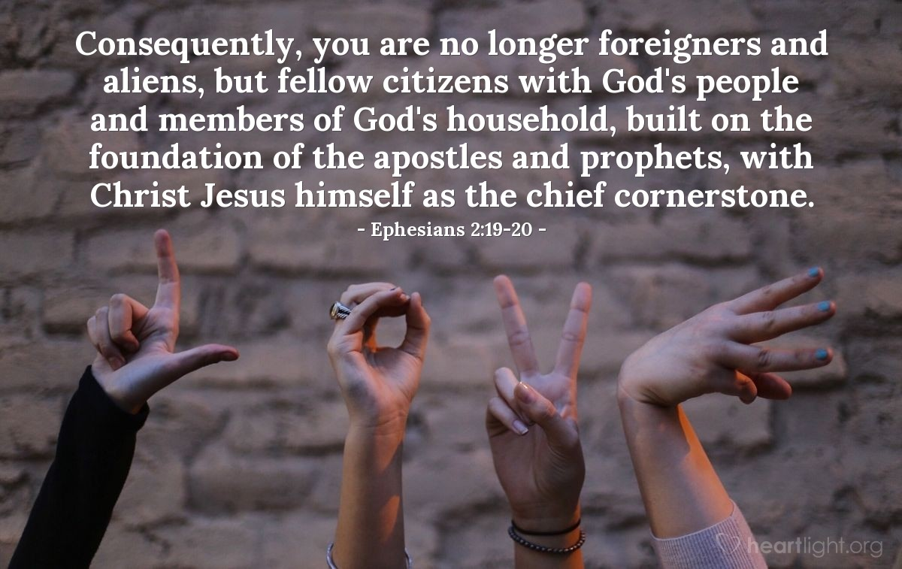
Courtesy of https://www.heartlight.org/

