Ephesians 1 Chosen before the world's foundation. ES
Efesios 1 Escogidos antes de la fundación del mundo. ES

Lesson developed by John M. Wharton October 5, 2022
http://www.biblestudyadventures.com/
Sources -
From theWord Bible program http://www.theword.net/ . Generally King James Version.
Greek, Hebrew definitions Mickelson's Enhanced Strong's, Brown-Driver-Briggs', Thayer's generally.

In Ephesians 1 Paul praise God and prays for them.  God has chosen us before the world's foundations and predestined us to adoption through Jesus.  We are ransomed back and our sins pardoned through Jesus blood.  God in His purposes, which He always accomplishes, has predestined us to an inheritance.  Paul prays that we will have full wisdom and revelation to see the hope in our calling from God. | En Efesios 1 Pablo alaba a Dios y ora por ellos.  Dios nos escogió antes de la fundación del mundo y nos predestinó a adopción por medio de Jesús.  Somos rescatados y nuestros pecados son perdonados a través de la sangre de Jesús.  Dios en sus propósitos, que siempre cumple, nos ha predestinado a una herencia.  Pablo ora para que tengamos plena sabiduría y revelación para ver la esperanza en nuestro llamado de Dios.

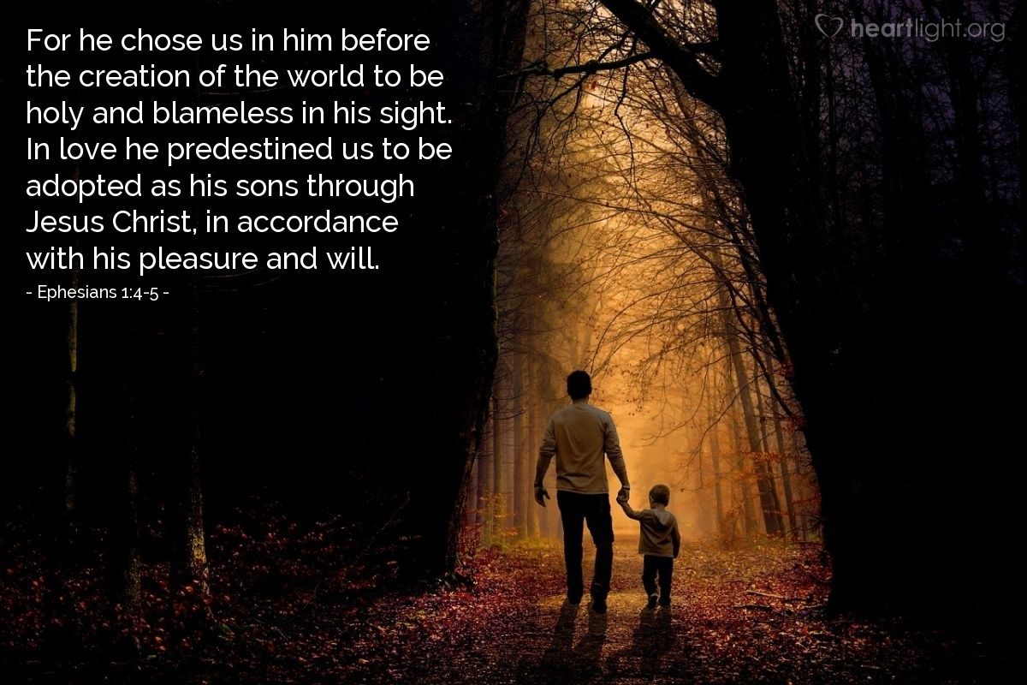
Courtesy of https://www.heartlight.org/

To the Saints in Ephesus.  Eph 1:1 AKJV/PCE Paul, an apostle of Jesus Christ by the will of God, to the saints which are at Ephesus, and to the faithful in Christ Jesus:  Eph 1:2 AKJV/PCE Grace be to you, and peace, from God our Father, and from the Lord Jesus Christ.  Paul called by Jesus Christ according to the will of God the Father.  Paul's greeting to the Ephesians is very similar to that used in Roman 1:7 and Galatians 1:3.  Rom 1:7 AKJV/PCE To all that be in Rome, beloved of God, called to be saints: Grace to you and peace from God our Father, and the Lord Jesus Christ.  Gal 1:3 AKJV/PCE Grace be to you and peace from God the Father, and from our Lord Jesus Christ,  Chosen before the world's foundation!  Eph 1:3 AKJV/PCE Blessed be the God and Father of our Lord Jesus Christ, who hath blessed us with all spiritual blessings in heavenly places in Christ:  Eph 1:4 AKJV/PCE According as he hath chosen us in him before the foundation of the world, that we should be holy and without blame before him in love:  Eph 1:5 AKJV/PCE Having predestinated us unto the adoption of children by Jesus Christ to himself, according to the good pleasure of his will,  The Father has blessed us with all spiritual blessings in heaven.  As He has also chosen us for Himself before He founded this world.  Chosen = 1. to pick out, choose, to pick or choose out for one's self  a. choosing one out of many, i.e. Jesus choosing his disciples . . . (Thayer).  Predestined = 1. to predetermine, decide beforehand  2. in the NT of God decreeing from eternity . . . (Thayer).  That doesn't mean that we have to be a Christian.  That is a choice we have to make.  And we have to continue in the faith after we become a Christian.  Paul tells the Galatians that if they get circumcised to keep the law that they have fallen = dropped away from the faith!  Gal 5:1 AKJV/PCE Stand fast therefore in the liberty wherewith Christ hath made us free, and be not entangled again with the yoke of bondage.  Gal 5:2 AKJV/PCE Behold, I Paul say unto you, that if ye be circumcised, Christ shall profit you nothing.  Gal 5:3 AKJV/PCE For I testify again to every man that is circumcised, that he is a debtor to do the whole law.  Gal 5:4 AKJV/PCE Christ is become of no effect unto you, whosoever of you are justified by the law; ye are fallen from grace.  Paul also tell us in Hebrews to keep on going to Church and having fellowship with other Believers.  If we don't that is a sin.  And intentionally continuing in a sin will lead to judgment.  Heb 10:25 AKJV/PCE Not forsaking the assembling of ourselves together, as the manner of some is; but exhorting one another: and so much the more, as ye see the day approaching.  Heb 10:26 AKJV/PCE For if we sin wilfully after that we have received the knowledge of the truth, there remaineth no more sacrifice for sins,  Heb 10:27 AKJV/PCE But a certain fearful looking for of judgment and fiery indignation, which shall devour the adversaries.  Heb 10:28 AKJV/PCE He that despised Moses' law died without mercy under two or three witnesses:  Heb 10:29 AKJV/PCE Of how much sorer punishment, suppose ye, shall he be thought worthy, who hath trodden under foot the Son of God, and hath counted the blood of the covenant, wherewith he was sanctified, an unholy thing, and hath done despite unto the Spirit of grace?  POINT – Just because God has chosen us = picked us and predestined us entering into our life and working to lead us to Him does not guarantee that we will choose to become a Christian or stay in the faith.  Bought by Jesus blood!  Eph 1:6 AKJV/PCE To the praise of the glory of his grace, wherein he hath made us accepted in the beloved.  Eph 1:7 AKJV/PCE In whom we have redemption through his blood, the forgiveness of sins, according to the riches of his grace;  Eph 1:8 AKJV/PCE Wherein he hath abounded toward us in all wisdom and prudence;  Eph 1:9 AKJV/PCE Having made known unto us the mystery of his will, according to his good pleasure which he hath purposed in himself:  Eph 1:10 AKJV/PCE That in the dispensation of the fulness of times he might gather together in one all things in Christ, both which are in heaven, and which are on earth; even in him:  God deserves our praise for His graciousness that He has placed on us in Christ.  We are fully ransomed and our sins pardoned through Jesus blood.  This is a wealth of God's grace toward us.  Paul's wording is that in doing all of this God has super abounded or even excessively abounded to us with wisdom and mental activity or even moral insight.  God has actually shown us His secret that He delighted in planning to do.  That secret was to at the right time (the completion of time or of the prophecies) to gather all things under Christ.  Eph 1:10 ISV to usher in the fullness of the times and to bring together in the Messiah all things in heaven and on earth.  Predestined by the Father!  Eph 1:11 AKJV/PCE In whom also we have obtained an inheritance, being predestinated according to the purpose of him who worketh all things after the counsel of his own will:  Eph 1:12 AKJV/PCE That we should be to the praise of his glory, who first trusted in Christ.  In Christ we have an inheritance since we've been predestined = foreordained, appointed beforehand (Thayer) according to the plans of the Father's who does everything He plans to do.  Thus God will be praised for His glory = His judgments, views (Thayer) because of our trust, our hope in Christ before we see it all completed.  Sealed with the Holy Spirit.  Eph 1:13 AKJV/PCE In whom ye also trusted, after that ye heard the word of truth, the gospel of your salvation: in whom also after that ye believed, ye were sealed with that holy Spirit of promise,  Eph 1:14 AKJV/PCE Which is the earnest of our inheritance until the redemption of the purchased possession, unto the praise of his glory.  We've heard the truth of the Gospel message of salvation and have believed it. We've trusted in Christ = placed our hope in Him before we see everything accomplished.  And we are sealed = stamped for security (Thayer) with the Holy Spirit as God promised.  That Holy Spirit inside of us is an earnest (KJV) guarantee (ISV) of our inheritance until the time that our redemption is fully completed.  When we buy a piece of land we pay a little money up front. We call that the earnest money. It is a guarantee that we will go ahead and buy the land and pay the rest of the money.  Praise God for His glory – His plans and efforts for us.  The Ephesians have faith in Jesus.  Eph 1:15 AKJV/PCE Wherefore I also, after I heard of your faith in the Lord Jesus, and love unto all the saints,  Eph 1:16 AKJV/PCE Cease not to give thanks for you, making mention of you in my prayers;  Eph 1:17 AKJV/PCE That the God of our Lord Jesus Christ, the Father of glory, may give unto you the spirit of wisdom and revelation in the knowledge of him:  Eph 1:18 AKJV/PCE The eyes of your understanding being enlightened; that ye may know what is the hope of his calling, and what the riches of the glory of his inheritance in the saints,  Eph 1:19 AKJV/PCE And what is the exceeding greatness of his power to us-ward who believe, according to the working of his mighty power,  Paul has heard about the Ephesians and their faith in Jesus and their love for all the Saints.  And he continues to thank God for them and to pray for them.  Paul is praying that God the Father will give them a spirit of wisdom = 1. wisdom, broad and full of intelligence; used of the knowledge of very diverse matters . . . (Thayer)  and a revelation = disclosure (M-Strongs) in knowledge =  1. precise and correct knowledge  a. used in the NT of the knowledge of things ethical and  divine . . . (Thayer)  Paul wants their understanding enlightened = brightened up (M-Strongs) so they can see this hope we have in God's calling us and of God's rich plans that He has we Christian's inheritance.  Paul also wants them to understand God's incredible levels of power beyond any usual mark we can understand which He has demonstrated in His works when He raised Him from the dead (see verse 20 below).  God's power raised Jesus from death!  Eph 1:20 AKJV/PCE Which he wrought in Christ, when he raised him from the dead, and set him at his own right hand in the heavenly places,  Eph 1:21 AKJV/PCE Far above all principality, and power, and might, and dominion, and every name that is named, not only in this world, but also in that which is to come:  Eph 1:22 AKJV/PCE And hath put all things under his feet, and gave him to be the head over all things to the church,  Eph 1:23 AKJV/PCE Which is his body, the fulness of him that filleth all in all.  The Father used His power when He raised Christ from the dead and set Him on the Father's right hand in heaven.  Far above all principality, and power, and might, and dominion  Those principalities and powers are angelic beings. Probably the angelic forces that have fallen with Satan. Paul mentions them with angels in Romans 8:38.  Rom 8:38 AKJV/PCE For I am persuaded, that neither death, nor life, nor angels, nor principalities, nor powers, nor things present, nor things to come,  Rom 8:39 AKJV/PCE Nor height, nor depth, nor any other creature, shall be able to separate us from the love of God, which is in Christ Jesus our Lord.  Paul is saying that Jesus has power and authority over them. In Galatians 2:18 we see Paul mention that some were worshiping angels.  It's likely that Paul is making this point here to establish that however powerful these principalities and powers may be, the Father has placed Jesus on His right side – the side or power.  The Father has also given Jesus the authority and power far over all of these beings. The Father has placed all things under under Jesus feet (Eph. 1:22).  Ellicott - . . . St. Paul mostly employs this whole group of words, especially in the Epistles of the Captivity, with a manifest reference to angelic powers of good or evil. Thus in Rom. 8:38 we read, of “angels, and principalities, and powers” (as in 1Pe. 3:22, “angels, and authorities, and powers”); in Eph. 3:10 of this Epistle, of “principalities and powers in the heavenly places;” and in Eph. 6:12, of “wrestling not against flesh and blood, but against principalities and powers,” &c.; and in Col. 1:16, of “things in heaven and earth, visible and invisible, whether they be thrones, or dominions, or principalities, or powers.” . . .  Thus the Father has put everything under Christ's authority.  He is the head of the Church.  Jesus who fills and controls all things is full in the church. What an incredible thought that is.  Col 2:9 AKJV/PCE For in him dwelleth all the fulness of the Godhead bodily.  Col 2:10 AKJV/PCE And ye are complete in him, which is the head of all principality and power:  Paul says that the Church is Christ's body. And the Church is the fullness or even over fullness of He (Christ) who is completely filling everything. | A los Santos en Éfeso.  Eph 1:1 RVG10 Pablo, apóstol de Jesucristo por la voluntad de Dios, a los santos que están en Éfeso, y a los fieles en Cristo Jesús.  Eph 1:2 RVG10 Gracia sea a vosotros, y paz de Dios nuestro Padre y del Señor Jesucristo.  Pablo llamado por Jesucristo según la voluntad de Dios Padre.  El saludo de Pablo a los Efesios es muy similar al usado en Romanos 1:7 y Gálatas 1:3.  Rom 1:7 RVG10 A todos los que estáis en Roma, amados de Dios, llamados a ser santos. Gracia y paz a vosotros, de Dios nuestro Padre y del Señor Jesucristo.  Gal 1:3 RVG10 Gracia sea a vosotros, y paz de Dios el Padre y de nuestro Señor Jesucristo,  Elegido antes de la fundación del mundo!  Eph 1:3 RVG10 Bendito sea el Dios y Padre de nuestro Señor Jesucristo, el cual nos ha bendecido con toda bendición espiritual en los lugares celestiales en Cristo,  Eph 1:4 RVG10 según nos escogió en Él antes de la fundación del mundo, para que fuésemos santos y sin mancha delante de Él, en amor,  Eph 1:5 RVG10 habiéndonos predestinado para ser adoptados hijos suyos por medio de Jesucristo, según el beneplácito de su voluntad,  El Padre nos ha bendecido con todas las bendiciones espirituales en el cielo.  Como también Él nos ha elegido para Sí mismo antes de fundar este mundo.  Elegido (Traductor de Google) = 1. elegir, elegir, elegir o elegir por uno mismo  una. escogiendo a uno entre muchos, es decir, Jesús escogiendo a sus discípulos. . . (Thayer).  Predestinado (Google Translate) = 1. predeterminar, decidir de antemano  2. en el NT de Dios decretando desde la eternidad. . . (Thayer).  Eso no significa que tenemos que ser cristianos.  Esa es una elección que tenemos que hacer.  Y tenemos que continuar en la fe después de convertirnos en cristianos.  Pablo les dice a los gálatas que si se circuncidan para guardar la ley, se han caído = ¡se han apartado de la fe!  Gal 5:1 RVG10 Estad, pues, firmes en la libertad con que Cristo nos hizo libres; y no os sujetéis de nuevo al yugo de esclavitud.  Gal 5:2 RVG10 He aquí, yo Pablo os digo que si os circuncidáis, de nada os aprovechará Cristo.  Gal 5:3 RVG10 Y otra vez testifico a todo hombre que se circuncidare, que está obligado a guardar toda la ley.  Gal 5:4 RVG10 Cristo ha venido a ser sin efecto para vosotros los que por la ley os justificáis; de la gracia habéis caído.  Pablo también nos dice en Hebreos que sigamos yendo a la Iglesia y teniendo comunión con otros creyentes.  Si no lo hacemos, es pecado.  Y continuar intencionalmente en un pecado conducirá al juicio.  Heb 10:25 RVG10 no dejando nuestra congregación, como algunos tienen por costumbre, sino exhortándonos unos a otros; y tanto más, cuanto veis que aquel día se acerca.  Heb 10:26 RVG10 Porque si pecáremos voluntariamente después de haber recibido el conocimiento de la verdad, ya no queda más sacrificio por el pecado,  Heb 10:27 RVG10 sino una horrenda expectación de juicio y hervor de fuego que ha de devorar a los adversarios.  Heb 10:28 RVG10 El que menospreciare la ley de Moisés, por el testimonio de dos o de tres testigos muere sin ninguna misericordia.  Heb 10:29 RVG10 ¿De cuánto mayor castigo pensáis que será digno, el que pisoteare al Hijo de Dios, y tuviere por inmunda la sangre del pacto en la cual fue santificado, e hiciere afrenta al Espíritu de gracia?  PUNTO – El hecho de que Dios nos haya elegido = nos escogió y nos predestinó al entrar en nuestra vida y trabajar para llevarnos a Él no garantiza que elegiremos convertirnos en cristianos para permanecer en la fe.  ¡Comprado por sangre de Jesús!  Eph 1:6 RVG10 para alabanza de la gloria de su gracia, en la cual nos hizo aceptos en el Amado,  Eph 1:7 RVG10 en quien tenemos redención por su sangre, la remisión de pecados, según las riquezas de su gracia,  Eph 1:8 RVG10 que sobreabundó para con nosotros en toda sabiduría e inteligencia;  Eph 1:9 RVG10 dándonos a conocer el misterio de su voluntad, según su beneplácito, el cual se había propuesto en sí mismo;  Eph 1:10 RVG10 que en la dispensación del cumplimiento de los tiempos, había de reunir todas las cosas en Cristo, así las que están en el cielo, como las que están en la tierra, aun en Él.  Dios merece nuestra alabanza por Su gracia que ha puesto sobre nosotros en Cristo.  Estamos completamente rescatados y nuestros pecados son perdonados a través de la sangre de Jesús.  Esta es una riqueza de la gracia de Dios hacia nosotros.  Las palabras de Pablo son que al hacer todo esto, Dios ha sobreabundado o incluso sobreabundado en nosotros con sabiduría y actividad mental o incluso perspicacia moral.  Dios realmente nos ha mostrado Su secreto que se deleitó en planear hacer.  Ese secreto era para en el momento adecuado (el cumplimiento del tiempo o de las profecías) reunir todas las cosas bajo Cristo.  Eph 1:10 NTV Y el plan es el siguiente: a su debido tiempo, Dios reunirá todas las cosas y las pondrá bajo la autoridad de Cristo, todas las cosas que están en el cielo y también las que están en la tierra.  ¡Predestinado por el Padre!  Eph 1:11 RVG10 En quien también obtuvimos herencia, habiendo sido predestinados conforme al propósito de Aquél que hace todas las cosas según el consejo de su voluntad;  Eph 1:12 RVG10 para que seamos para alabanza de su gloria, nosotros quienes primero confiamos en Cristo.  En Cristo tenemos una herencia ya que hemos sido predestinados (Google Translate) = predestinados, designados de antemano (Thayer) según los planes del Padre que hace todo lo que Él planea hacer.  Así Dios será alabado por Su gloria (Google Translate) = Sus juicios, puntos de vista (Thayer) debido a nuestra confianza, nuestra esperanza en Cristo antes de que lo veamos todo completado.  Sellado con el Espíritu Santo.  Eph 1:13 RVG10 En el cual también confiasteis vosotros, habiendo oído la palabra de verdad, el evangelio de vuestra salvación; en quien también, desde que creísteis, fuisteis sellados con el Espíritu Santo de la promesa,  Eph 1:14 RVG10 que es las arras de nuestra herencia hasta la redención de la posesión adquirida, para alabanza de su gloria.  Hemos oído la verdad del mensaje evangélico de salvación y lo hemos creído. Hemos confiado en Cristo = hemos puesto nuestra esperanza en Él antes de ver todo cumplido.  Y estamos sellados = estampados para seguridad (Thayer) con el Espíritu Santo como Dios prometió.  Ese Espíritu Santo dentro de nosotros es una ferviente (KJV) garantía (ISV) de nuestra herencia hasta el momento en que nuestra redención se complete por completo.  Cuando compramos un terreno, pagamos un poco de dinero por adelantado. A eso lo llamamos dinero en arras. Es una garantía de que seguiremos adelante y compraremos la tierra y pagaremos el resto del dinero.  Alabado sea Dios por Su gloria – Sus planes y esfuerzos para nosotros.  Los efesios tienen fe en Jesús.  Eph 1:15 RVG10 Por lo cual también yo, habiendo oído de vuestra fe en el Señor Jesús, y amor para con todos los santos,  Eph 1:16 RVG10 no ceso de dar gracias por vosotros, haciendo mención de vosotros en mis oraciones,  Eph 1:17 RVG10 para que el Dios de nuestro Señor Jesucristo, el Padre de gloria, os dé espíritu de sabiduría y de revelación en el conocimiento de Él;  Eph 1:18 RVG10 alumbrando los ojos de vuestro entendimiento, para que sepáis cuál es la esperanza de su llamamiento, y cuáles las riquezas de la gloria de su herencia en los santos;  Eph 1:19 RVG10 y cuál la supereminente grandeza de su poder para con nosotros los que creemos, según la operación del poder de su fortaleza,  Pablo ha oído hablar de los efesios y su fe en Jesús y su amor por todos los santos.  Y sigue dando gracias a Dios por ellos y orando por ellos.  Pablo está orando para que Dios Padre les dé un espíritu de sabiduría (Google Translate) = 1. sabiduría, amplia y llena de inteligencia; utilizado del conocimiento de materias muy diversas. . . (Thayer)  y una revelación (Google Translate) = revelación (M-Strongs) en conocimiento =  1. conocimiento preciso y correcto  una. usado en el NT del conocimiento de las cosas ético y  divino . . . (Thayer)  Pablo quiere que su entendimiento sea iluminado (Google Translate) = iluminado (M-Strongs) para que puedan ver esta esperanza que tenemos en el llamado de Dios y en los ricos planes de Dios que Él tiene para nosotros como herencia cristiana.  Pablo también quiere que entiendan los increíbles niveles de poder de Dios más allá de cualquier marca habitual que podamos entender y que Él ha demostrado en Sus obras cuando lo resucitó de entre los muertos (ver el versículo 20 a continuación).  ¡El poder de Dios resucitó a Jesús de la muerte!  Eph 1:20 RVG10 la cual operó en Cristo, resucitándole de los muertos, y sentándole a su diestra en los lugares celestiales,  Eph 1:21 RVG10 sobre todo principado y potestad y potencia y señorío, y sobre todo nombre que se nombra, no sólo en este mundo, sino también en el venidero;  Eph 1:22 RVG10 y sometió todas las cosas bajo sus pies, y lo dio por cabeza sobre todas las cosas a la iglesia,  Eph 1:23 RVG10 la cual es su cuerpo, la plenitud de Aquél que todo lo llena en todo.  El Padre usó Su poder cuando resucitó a Cristo de entre los muertos y lo puso a la diestra del Padre en el cielo.  Muy por encima de todo principado y potestad y poder y señorío  Esos principados y potestades son seres angélicos. Probablemente las fuerzas angelicales que han caído con Satanás. Pablo los menciona con los ángeles en Romanos 8:38.  Rom 8:38 RVG10 Por lo cual estoy seguro que ni la muerte, ni la vida, ni ángeles, ni principados, ni potestades, ni lo presente, ni lo por venir,  Rom 8:39 RVG10 ni lo alto, ni lo profundo, ni ninguna otra criatura nos podrá separar del amor de Dios que es en Cristo Jesús Señor nuestro.  Pablo está diciendo que Jesús tiene poder y autoridad sobre ellos. En Gálatas 2:18 vemos que Pablo menciona que algunos adoraban a ángeles.  Es probable que Pablo esté destacando este punto aquí para establecer que, por muy poderosos que sean estos principados y potestades, el Padre ha puesto a Jesús a Su lado derecho: el lado o el poder.  El Padre también le ha dado a Jesús la autoridad y el poder sobre todos estos seres. El Padre ha puesto todas las cosas bajo los pies de Jesús (Efesios 1:22).  Ellicott (Traductor de Google) - . . . San Pablo emplea principalmente todo este grupo de palabras, especialmente en las Epístolas de la Cautividad, con una referencia manifiesta a los poderes angélicos del bien o del mal. Así en Rom. 8:38 leemos, de “ángeles, y principados y potestades” (como en 1Pe. 3:22, “ángeles, y autoridades y potestades”); en Eph. 3:10 de esta Epístola, de “principados y potestades en los lugares celestiales”; y en Eph. 6:12, de “luchar no contra sangre y carne, sino contra principados y potestades”, etc.; y en Col. 1:16, de “cosas en el cielo y en la tierra, visibles e invisibles, sean tronos, dominios, principados o potestades”. . . .  Así el Padre ha puesto todo bajo la autoridad de Cristo.  Él es la cabeza de la Iglesia.  Jesús, quien llena y controla todas las cosas, está lleno en la iglesia. Qué pensamiento tan increíble es ese.  Col 2:9 RVG10 Porque en Él habita corporalmente toda la plenitud de la Deidad,  Col 2:10 RVG10 y vosotros estáis completos en Él, el cual es la cabeza de todo principado y potestad.  Pablo dice que la Iglesia es el cuerpo de Cristo. Y la Iglesia es la plenitud o incluso la sobreplenitud de Él (Cristo) que va llenando todo por completo.

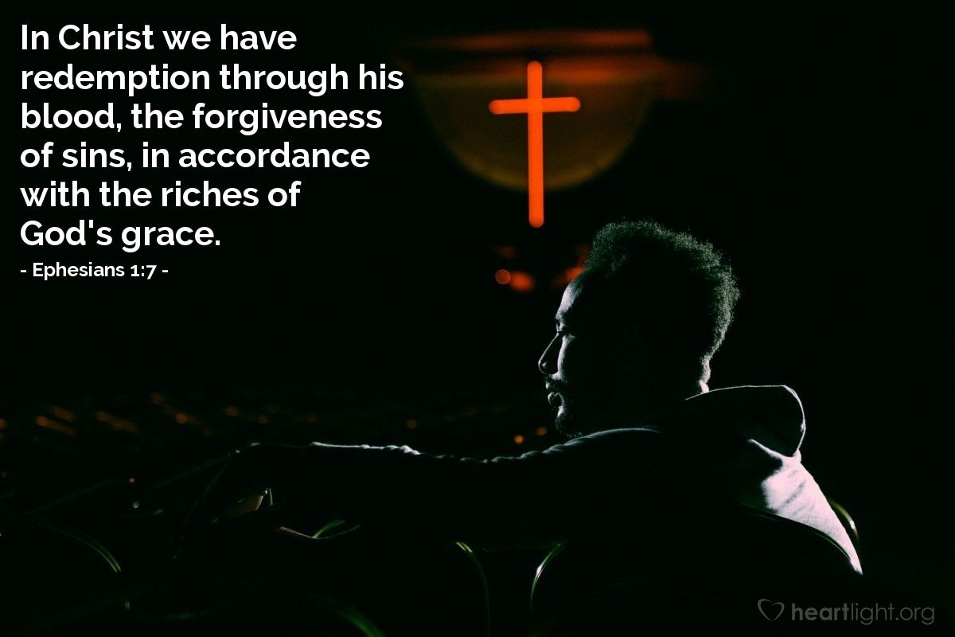
Courtesy of https://www.heartlight.org/

